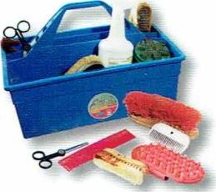
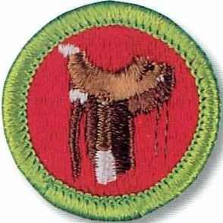
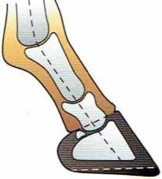
Troop 1292
# (o3A
M E R I T BA D G E S E R I E S
HORSEMANSHIP

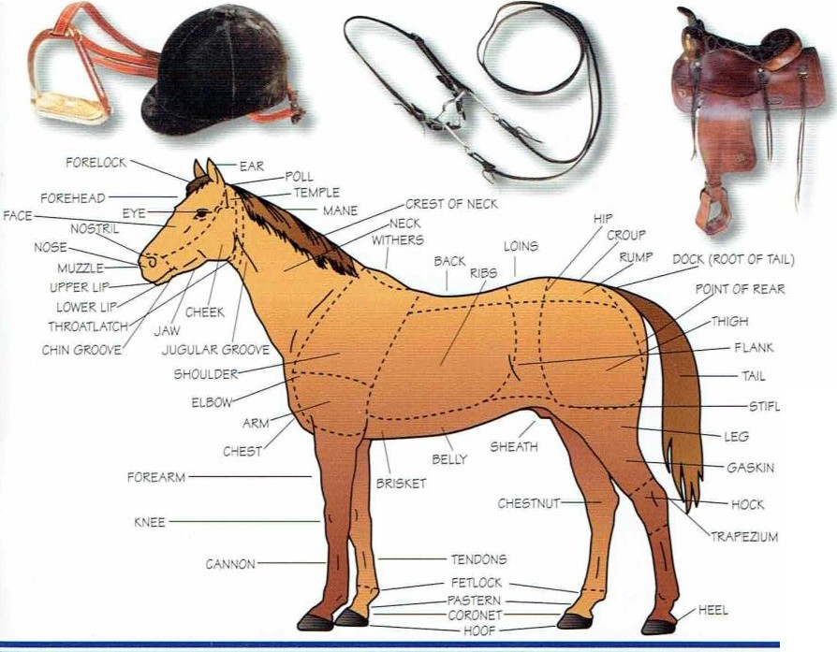BOY SCOUTS OF AMERICA
STIFL E
\ . I

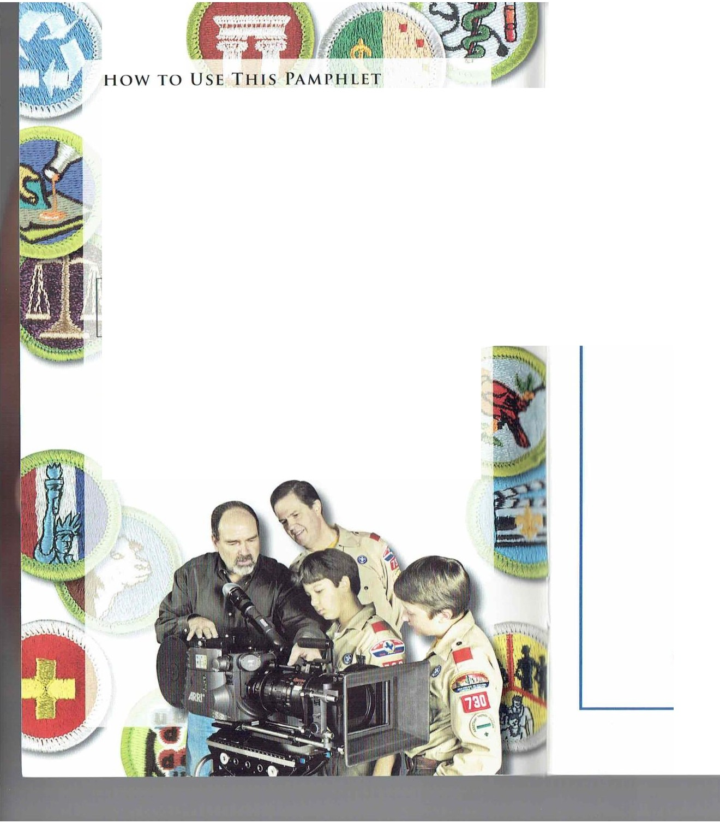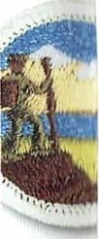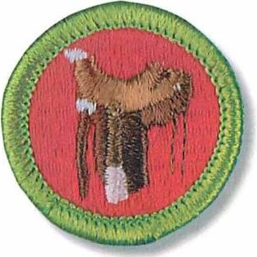

The secret to successfully earning a merit badge is for you to use both the pamphlet and t he suggestions of your counselor.
Your counselor can be as importa nt to you as a coach is to an athlete. Use all of t he resources your counselor can make available to you.
This may be the best chance you will have to lea rn about this particular subject. Make iicount.
If you or your counselor feels t hat any informat ion in this pamphlet is incorrecl. please lei us know. Please state your source of information.
Merit badge pamphlets are reprinted annually and requirements updated regularly. Your suggestions for improvement are welcome.

Send comment s along with a brief statement about yourself to Youth Development ,S209 • Boy Scouts of America • 1325 West Walnut Hill Lane • P.O. Box 152079 • Irving, TX 75015-2079.

W H O PAY S FO R T H I S PA M P H L ET?
This merit badge pamphlet is one in a series of more than 100 covering all kinds of hobby and career subject s. It is made available for you
to buy as J serv ice of the national and localcouncils. l:loy Scouts of America. The costs of the development ,writ ing. and editing of the merit badge pamphlets are paid for by the Boy Scouts of A merica in order to bring you the best book ala reaso nable price.
[)OY SCOUTS or A M E RI CA M E R I T gA DG E S E R I ES

HORSEMANSH IP

@IBOY SCOUTS OF AMERICA

- Show how to properly saddle and bridle a horse.
- Demonst rate how to safely mount and dismount a horse.

Requirements
- Do the following:
  - Describe the safet y precautions you should take when handling and caring for a horse.
  - Describe t he f re safety precautions you should take in a barn and around horses.

- Name t he IS main parts of a horse.

- Name four breeds of horses. Explain the special fea tures for which each breed is known.

- Describe the symptoms of colic. Name and describe four other horse health problems. ·',

5 . Expla in what conformation is and why it is important. _ Explain t he difference between la meness and unsoundness.

- Expla in the importa nce of hoof care and why a ho'rse might need to wear shoes.
- Demonstrate how to groom a horse, including picking hooves and caring for a horse after a ride.

- Explain how to determine what and how much to feed a horse a nd why the amount and kind of feed arc changed according to the act ivity level and t he breed of horse.

- Do t he follow ing:
  - Name 10 parts of t he saddle and bridle t hat you will use. and explain how to care for this equipment.

- Explain and demonst rate how to a pproach and lead a horse safely from a st all, corral, or field and how to t ie t he
horse securely.

- On level ground, continuously do t he following movements after safely mounting the horse. Do them correctly. at ease. and in harmony with t he horse.
  - Walk the horse in a straight line for 60 feel.
  - Wa lk the horse in a half-circle of not more than 16 feet in radius.
  - Trot or jog the horse in a st raight line for 60 feel.
cl. ·n-ot or jog the horse in a half-circle of not more t han 30 feet in radius.
I C ) UIC IIOIOC iii Ci 3lilll611l IIIIC IC ct.

bbjJC (CdlilC i) lilt IIOISC iii LIL 110( IIIOI C lllilll
79 5 I t dic!S

- Halt st raight.
f J,(. Back up st raight four paces.
)': Ilalt and dismount.

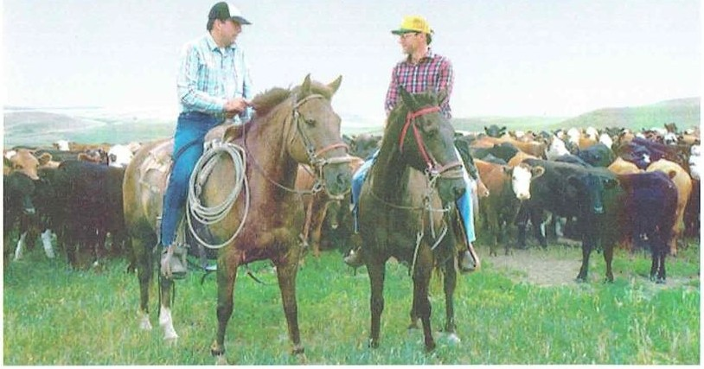35909
ISBN 978-0-8395-3298-9
©201O Boy Scouts of Amer ca 2010 Printing

BANG/Brainerd. MN 11-2010/057547
HORSEMANSHIP 3

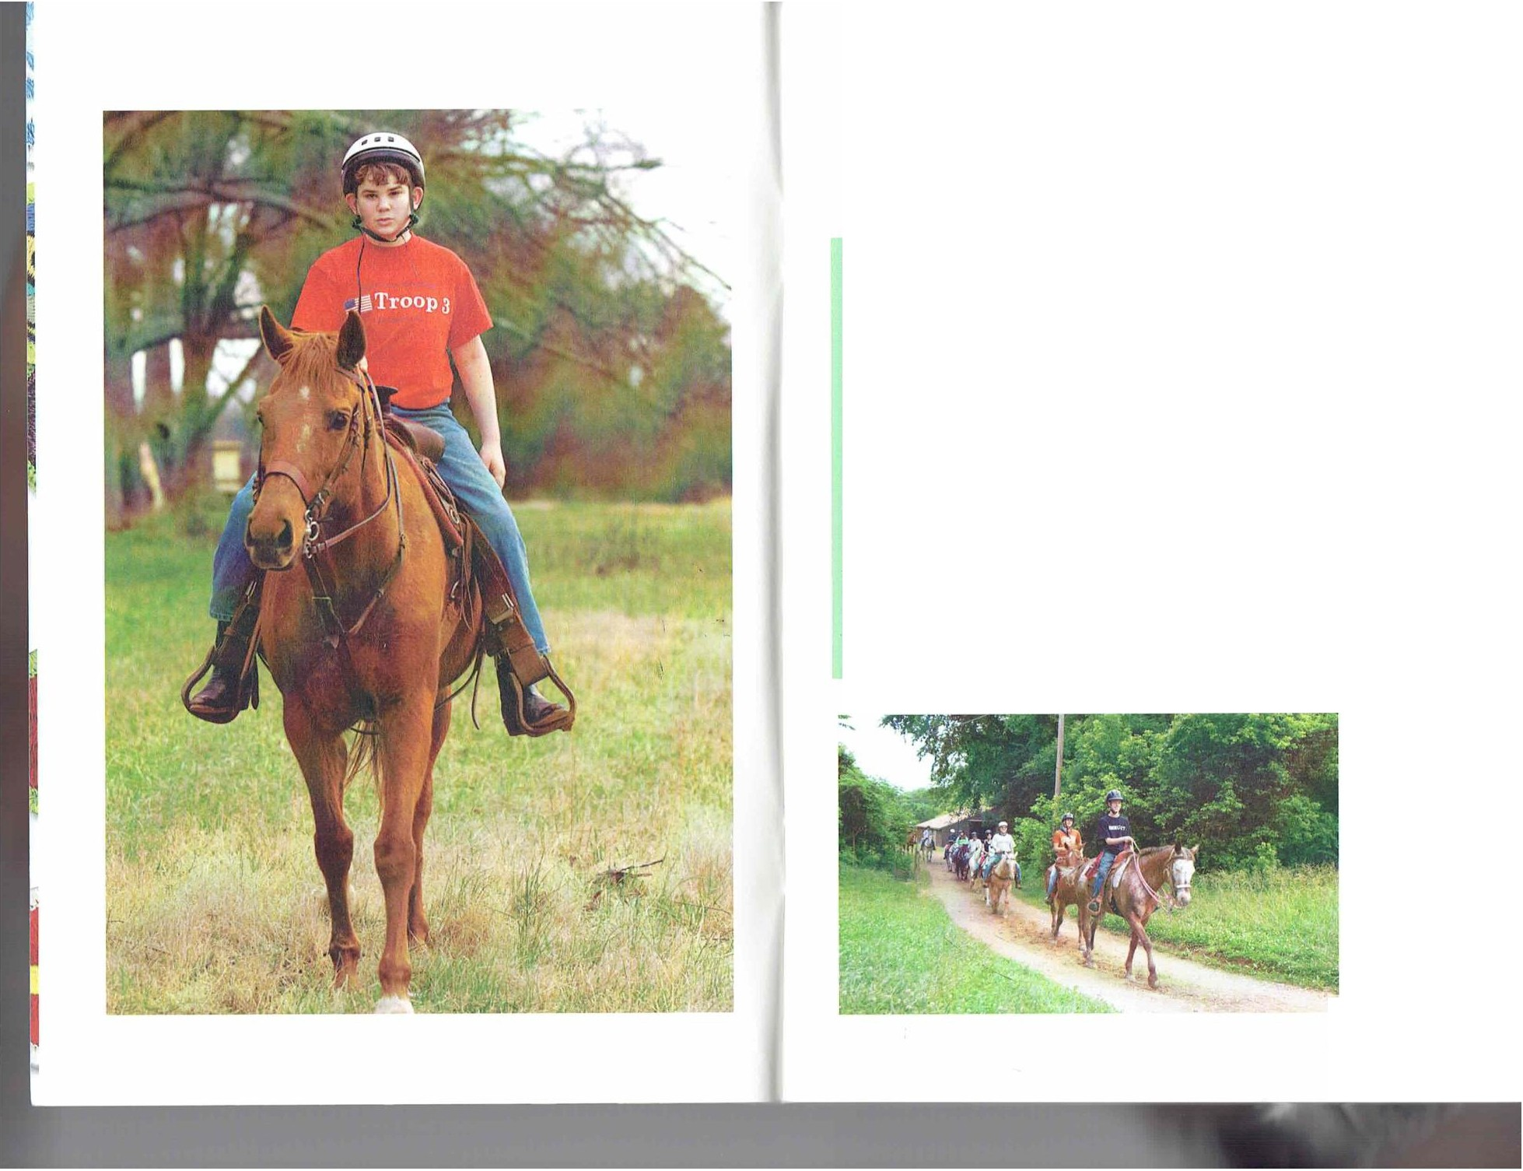

Contents
What Is Ilorsemanship? 7
The Ilorse 11
Choosing a Horse ... . ... ..... ..... . • 15
'lack . . ... . . .... . . • 27
Grooming and Care 35
He;illh M;itters 43
Feeding llorses ... ...• . .. ......• 5 1
Ready to Ride 55
Riding.. .. . ....... ..... ..... ..• 65
Ilorsemanship and You 77
llorsema nship Resources .. . .• 78

HORSEMANS HIP 5

\V l l lll h llOl(SIMANSIII I'?

What Is Horsemanship ?

The goalof a good horseman is 10 become so sensitive to the ent ire horse, 10 1he movements of ils body and to how the horse thinks, t hat the rider can sense trouble, anticipat e exact ly how the horse will reJcl,and move lo cont rol that reaction even before 1hc horse is Jware of its own feelings. A good rider will do these t hings wilhoul thinking, without even being able
to explain what he did.
Will you be a rider or just a passenger? "lb be J good rider you must know whal a horse is. You must understand the horse. and why it behaves as it does. You and your horse must become almost as one. Only t hen can each of you completely enjoy !he advantages of the other.
The horse is J flesh-and-blood creat ure,but it's also a
bunclle of instincts. If you understand the instinct s t hat cause a horse to acl in a certain way, you can use that knowleclge to become more skilled as a horsema n.

Part of the Herd
Though they possess individual personalities, horses hJve a herd inst inct. They do 1101 like lo be alone. Like other herd animals-animals thal are preyed upon-horses arc alert, timid, a nd insecure. Living in herds provides horses a sense of security and safety from real and perceived predators.
Horses also develop relationships w ithin a herd. Wild herds have a leader,and the ot her horses arc ranked behind this lead horse in a pecking order. This prevents fighting over food, water. and mates because a lower-ra nked horse almost always yields to a higher-ranked horse.

One of your goals as a horseman will be to soften
and improve your handling and riding skills so that the experience
is calm and comfortable for you and the horse. This will help you and the horse build mutualtrust.

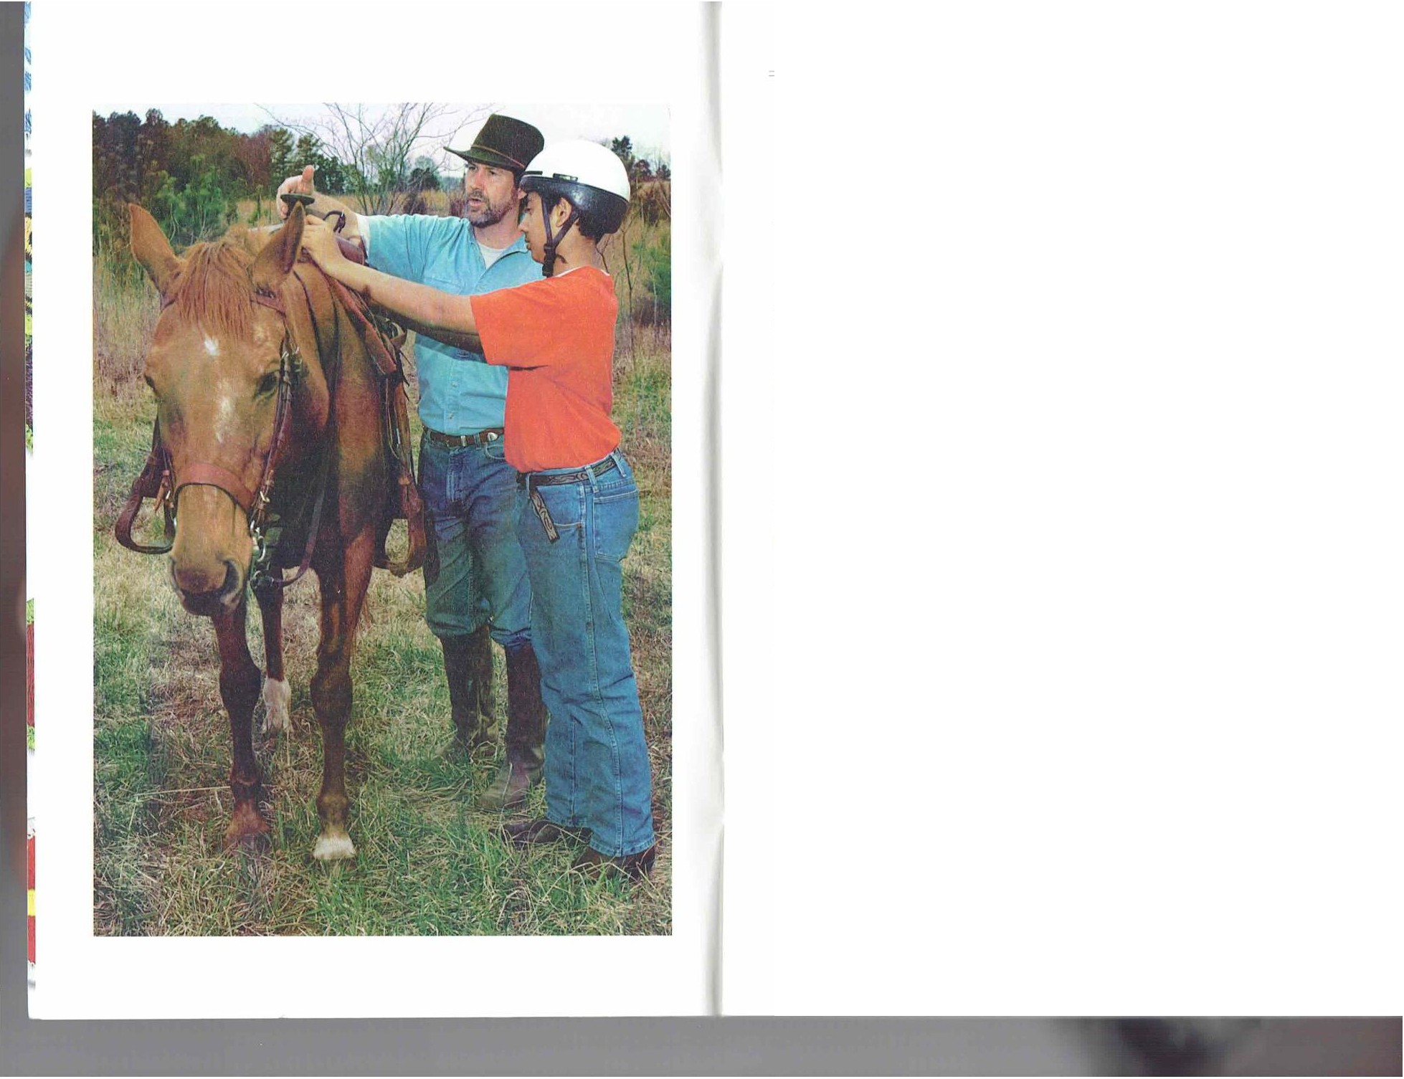
Fossils reveal that horses have been evolving for approximately
60 million years.The first horses were no bigger than dogs and had multiple toes rather than hooves.
HORSEMANSHIP 7

WIIJ\l I\ IIORSIM.\N\1111') - -· - ··• - -

Horse Terminology
  - A stallion is a male horse older than 4 years that is used for breeding.
  - A mare is a female horse older than 4 years.
  - A filly is a female horse younger than 4 years, and a colt is a male horse younger than 4 years.
  - A gelding is a castrated male horse of any age. A gelding cannot be used for breeding.
  - A yearling is a horse older than 1 year but not yet 2 years old.
  - A foal is a young, unweaned horse of either sex, and a weanling
is a newly weaned horse.

The leader of a wild herd usually is an older mare that the ot her horses respect. She leads the herd to food and safety and even settles disputes. somet imes using discipline. If a sta llion is part of the herd, he protects the herd and leads it to food and water while t he lead mare still leads the herd in social and day-to-clay mailers.
Domesticated horses a lso seek a leader. "lb practice good horsemanship,you will need to become the leader of your horse. The horse will seek direction, reassurance, food, and ·

L.1rge. funnel-like cars aid J horse's hear­ ing. The cars can rolalc in any direc1ion to pick up sounds Jnd v ibrJlions. A horse's
car position also is a signal of its mood. For instance, when its cars move back and forth, it is alert and list ening. The eJrs will usua lly hang toward the side when a horse is relaxing or dozing. When t he ears arc laid back. it indicates aggression or displeasure.
Ilorscs use their sense of smell to ident ify each 01hcr and ot her animals that could be predators. A horse's sexualbehavior also is affected by smell.
Because their eyes c;in move indepen­
dently and are positioned on the sides of the head, horses can sec almost all the way around their bodies except immediately in front of and behind them. where they have blind spots.
Ilorses also see well in t he dark. But their eyes do not focus like human eyes do; a horse must raise and lower it s head lo sec objects clearly.
Ilorses can detect the same four basic lilstes as humans: salty, sweet , sour, and bitter.

Wltt\ l I,IIOR\lMI\N\1111'!

A horse's ears point to where it is directing its attention.

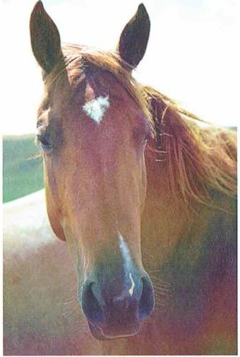
Humans and horses have a long history.At various times, horses were a source of food and clothing or were viewed in mythical or religious ways. People eventually learned that horses could be domes­ ticated and ridden.The invention of the wheel allowed people to put horses to work, hitching them to wagons and chariots for transporta­ tion, hauling, sporting events, and warfare.

8 HORSEMANSHIP
safety from you. If you do not become the
leader, the horse will try taking the role.

Instincts, Senses, and Behavior
One of the horse's most importilnl instinct s is defense. When start led or afraid. a horse's strongest impulse is to get away. Ilorses use their speed, agility, bucking. a nd kicking to defend themselves.
Horses also develop habits. Some habits, such as those that you t rain t he horse to do,are good and help foster your relationship with the horse. But some habits, such as biting. are bad. If you do not prevent or correct poor habits. the horse will be diff cult to manage.
Horses have highly developed hearing, smell. sight, taste, Louch. and what many call a sixt h sense, which a llows horses to recognize impending danger and to detect t he moods of people around them.
Some people believe horses have a sweet tooth, just as people do. You might notice that your horse likes to eat apples or molasses. for example. Many commercial horse feeds have added sweeteners to make the taste more appealing.
Touch is a way for horses to communicate with e.1ch other and humans. By grooming each other with tongue and teeth, horses keep clean and develop friendships. As you earn the Horsemanship merit badge, you will learn how grooming your horse w ill help you strengthen your relat ionship.

Horse Talk
Horses communicate through body language, vocalization, smell, taste, and touch.A horse might show displeasure by pinning back its ears, baring its teeth, biting, and turning to show its hind legs. Signs of aggression or excitement include squealing, snorting,and grunting. A horse might whinny or neigh if a mealis late or when separated from its usualcompanions.
HORSEMANSHIP 9

- - - 1 111 IIOll\l

:::,-
l\l
iS
<(
UJ
ll..

"z'

--'

lLI
--'
,= z
ll..
'2 v'
g

0 ""-'
]_ < iS
\j)
\j)
\'.)
<
I

--'
0 \'.) ll..
\l.l I

I-
'i: \
z
n\ I-
\
>L
g
J \'.)
I I

The Horse
You can learn a 101 by reading about horses, hul lhe besl and most fun way to learn is lo actually care for and ride a horse. 'laking lessons can speed up your learning. Bui firsl. learn lhe pans of a horse so 1ha1 you can disc uss Ihem with confidence.

Markings and Coat Colors
A variely of nalural markings and coal colors gives horses t heir dis1inc1 looks.
Common face markings include the following:
- Star-a white mark on the forehead
- St ripe-a narrow white mark from t he forehead to the nose
•·While muzzle-a broad white mark that covers the muzzle
- White lips-a white mark covering just the lip area

Star

Stripe

White muzzle

UJ tt r z
.,
"0'
.s::
"'
0
t":'
"'

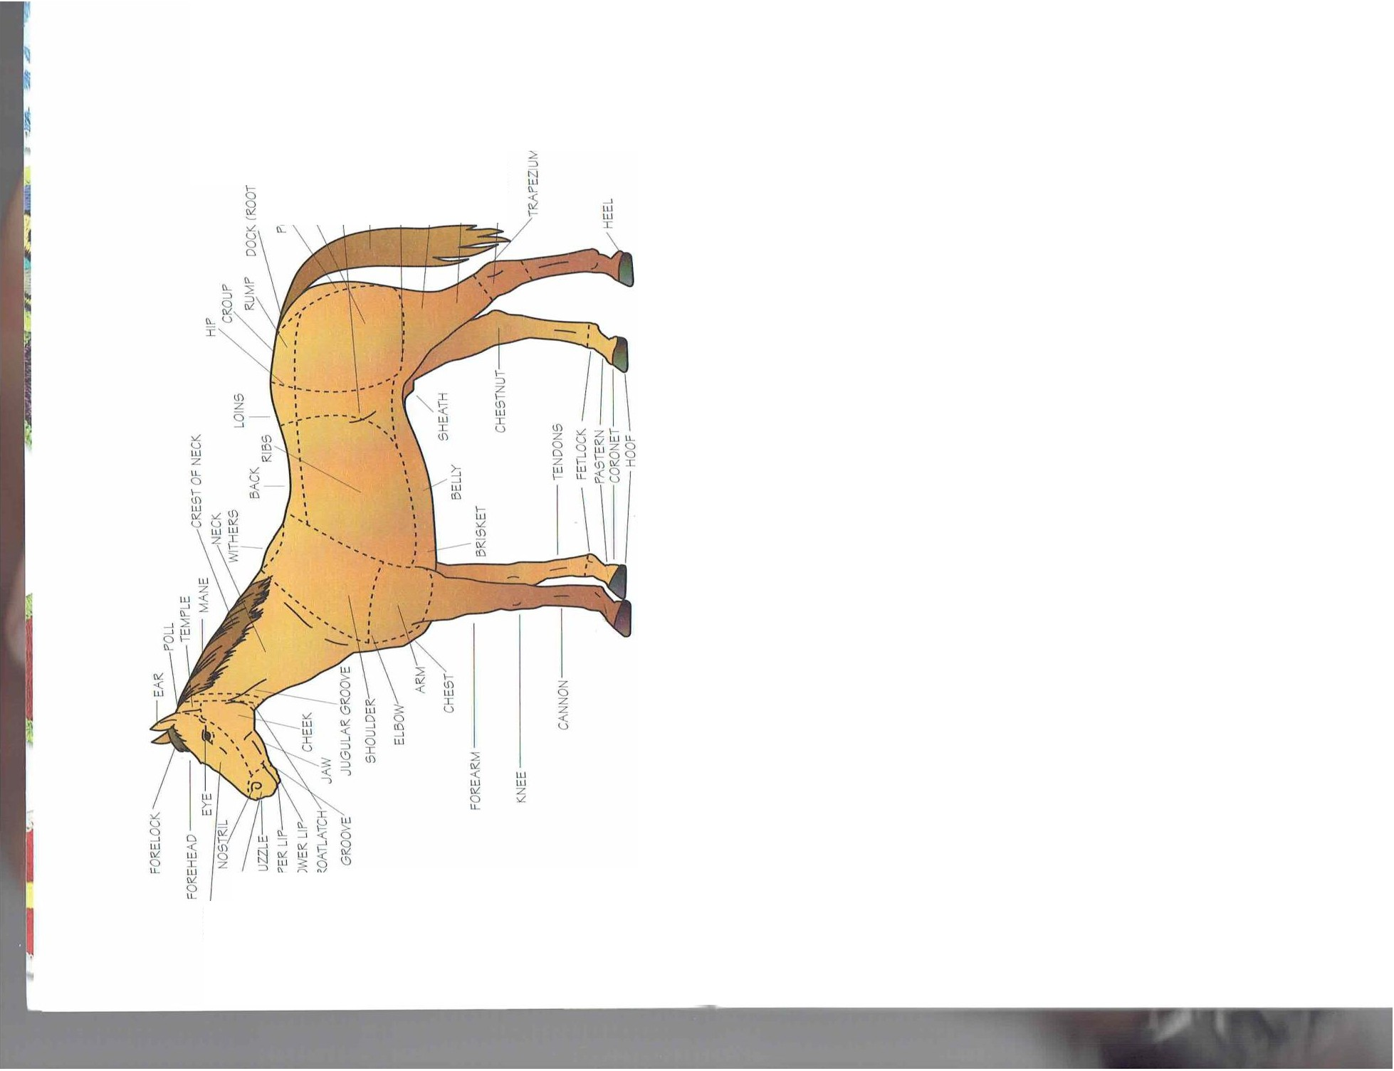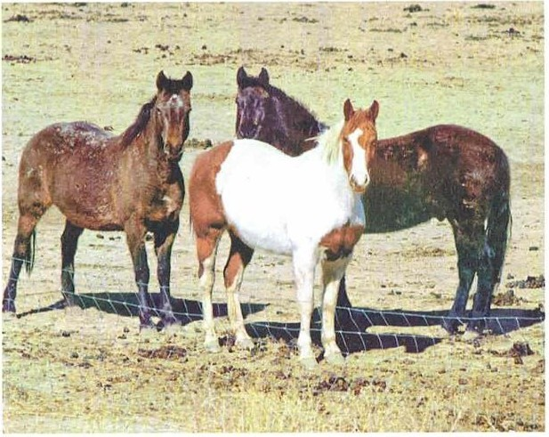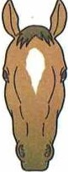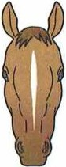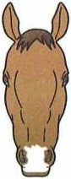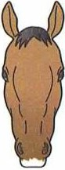

ll.l
u
.f
\j) ::, I- :i:
0 u Q.
7

White lips
HORSEMANSHIP 11

1111 l l nRSI

Interrupted stripe

;, ,;
Bald

- BIJze-a broad w hile stripe t hat runs from the foreheJd down t he nose bridge, ind covers the nost rils
- Interrupt ed stripe-a narrow. white m,1rk from t he forehead to the nose
- Snip-J white mark between the nost rils
- Bald-a mark similar to a blaze but wider. encompassing lhe eyes and moulh
Leg mJrkings include the following:
- Coronet-a while band around the coronet
- PJslern-white coloring from ihe hoof to the fet lock joinl
- Sock-w hile coloring from 1he hoof to the lop of t he fet lock joint
- Slacking-w hite coloring from the hoof up to or covering the knee

Coronet Pastern Sock Stricking
The most common colors of a horse are brown and black, but nearly any color combination is possible. Many horse colors have specific names. such as the following:
- Bily-a reddish coJt w ith a black mJne, tail, and points
- Cheslnut-various shades of gold and reddish brown, from pale to a rich reel
- Strawberry roan-a chestnut color mixed with while hairs
- Blue roan-black or brown mixed with white hairs
- Palomino-a golden coat with a pale tail and mane
- Pinto-two coat colors of irregular palterns, usually white and another color such as brown or black
1 111 IIOR\ I

The great variations in a horse's color boils down to genes. For instance, a buckskin carries the cream gene, which "dilutes" its red/ brown coat,giving it a yellow, cream, or gold coat.The buckskin also has black points such as on the mane, tail,and legs. Dun horses carry the dun gene, which gives the coat any color variation of yellow or cream. A dun always has a black dorsal stripe running down the middle of the back and some variation of other markings.The Appaloosa is a breed with distinctive dark patches over a white coat.

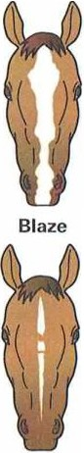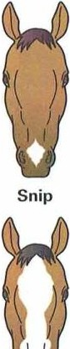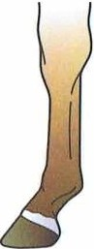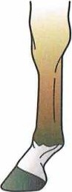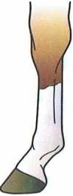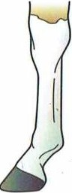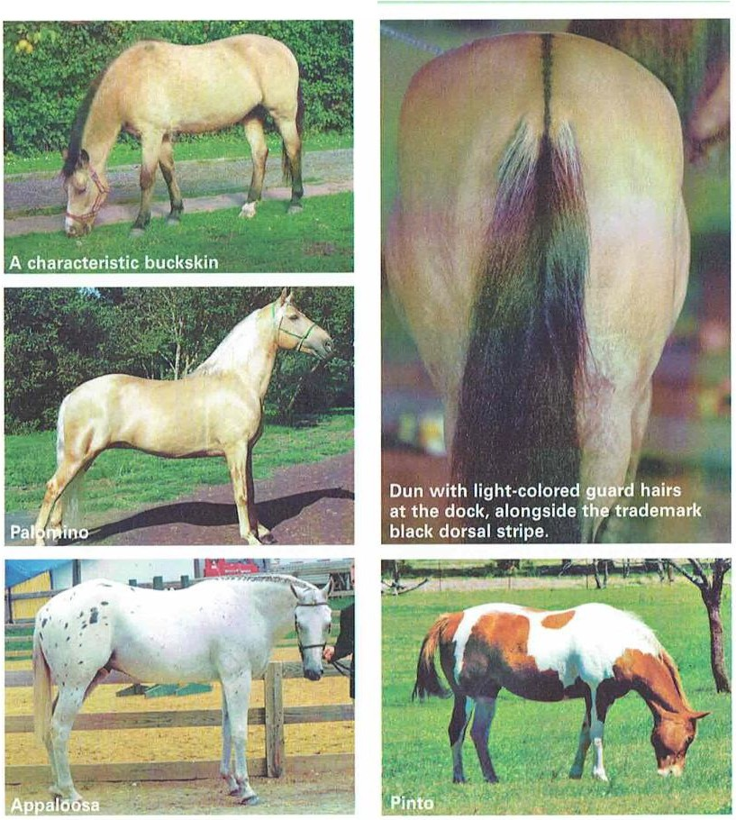12 HORSEMANSHIP
HORSEMANSH P 13

(. IHHl\lNl, A IIOR!

Choosing a Horse

Because horse breeds can be as varied as breeds of other animals, such as dogs and cats, it is important lo weigh lhc characteristics of each breed before choosing a horse. You will need to decide wha t factors arc besl for the purpose you have in mind for t he horse. whether riding for pleasure, working cattle, showing, or compet ing. Decide on the breed, age, size, and sex of t he horse accordingly.
Owning a horse is expensive and lime-consuming, so first determine why you wanl one. Deciding w het her you are able to handle the responsibility and ex pense takes greal considerat ion. If you decide to buy a horse, have an experi­ enced horseman help you select one. and have a vet erinarian
examine it. Buy from a knowledgeable and reputable horseman.

Horse Breeds
I\ breed of horse is an equine group that has a set of character­ istics that distinguish it from other horses. These characterist ics are preserved t hrough selective breeding over a period of lime.
Wit h purebred horses, the pedigree, or lineage, is recorded in a stud book. I\ male horse used for breeding often is called a st ud.St ud stables or farms provide
purebred male horses for breeding.

American Saddlebred
This breed. originally the Kentucky Saddler, was developed during the I9th cent ury in the southern United Stat es. Its ancestors include the Canadian Pacer, Narragansett Pacer, Morgan, Arabian, and Thoroughbred.

Equine describes anything relating to a horse or horse family.

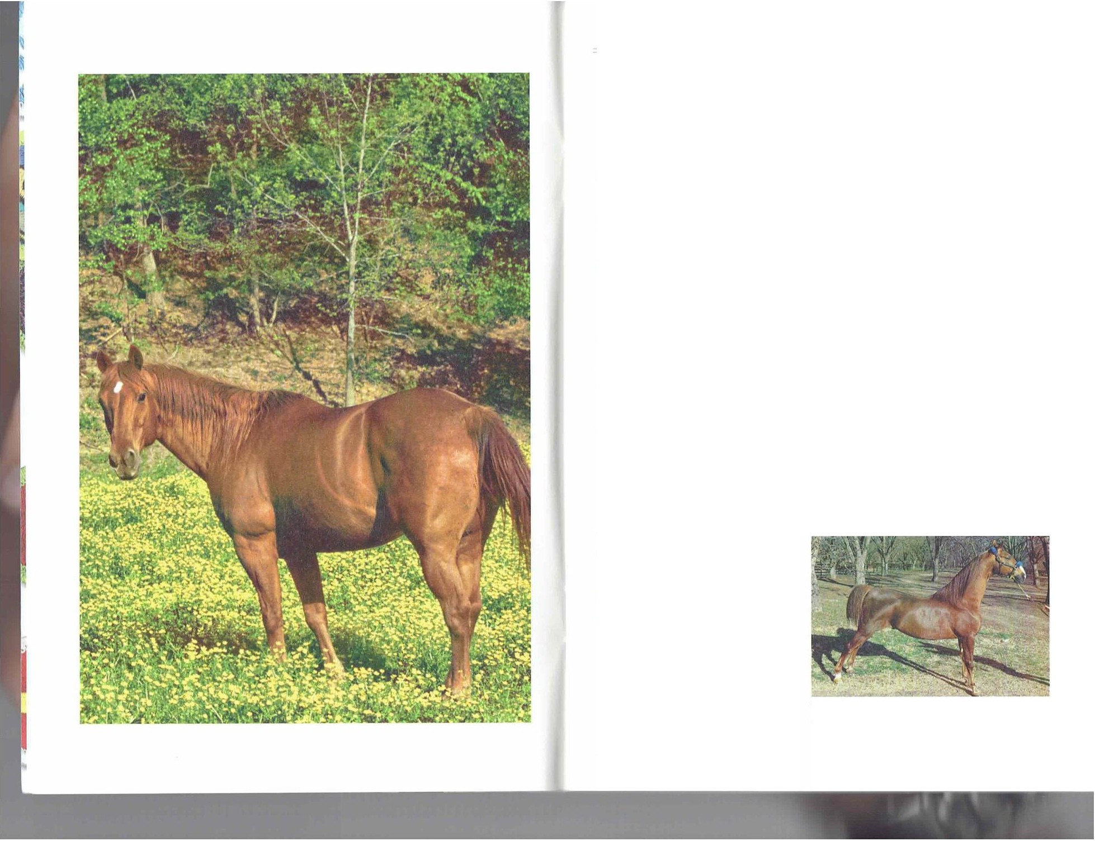
The American Saddlebred is an elegant and comfortable riding horse.
HORSEMANSHIP 15

CIIOO\IN<, A IIOR I
- ----- - - LIIOO\ IN(,A IIOR\ I

Gymkhana includes competitions where horse and rider compete against others
in timed events, including barrel racing, pole bending, and stake racing.

Because of ils high-stepped gilit. the breed is popular for recrciltionalriding and show competitions. faring especially well in the five-gaited, three-gaited. fine harness, µark, a nd pleasure categories. It also is popular for farm work and rid­ ing over rough terrain. American Saddlebreds have strength,
stamina , a nd a pleasa nt temperament. They usually arc bay- or chestnut-colored, but they also can be gr 1y, black, palomino. and roan. These horses usually stand I5 to 16 hands tall.

A horse is measured in hands. One hand equals 4 inches.The measurement starts fromthe top of the horse's withers. A pony is shorter than 57
inches, or 14.2 hands; miniatures are shorter than 34 inches, or 8.5 hands.

Appaloosa
The Appa loosa is il dist inctive and popular breed in the United States. The breed was developed by t he Nez Perce Indians in
the 18th cenlllry using stock t he Spanish conquistadors brought
10 the America s,but it was nearly wiped out in t he lale 1800s clue t o indiscriminat e breeding. In 1938, Claude Thompson, a wheat farmer from Moro,Oregon. wanted to preserve lhe breed and established the Appa loosa Ilorse Cl 1b. The club has been largely responsible for the breed's rebound.
The Appaloosa has five coal piltterns: blanket. marble, leopard. snowflake. and frost.
The A merican Appa loosa st ands

Arabian
The Arabian is considered the oldest and purest of all breeds. Developed in Arabia, the breed's purity has been carefully mainta ined for thousands of years. Arabians have been bred in the United Stales since Colonial t imes.
Its short head and dished (concave) face make t he Arabian unmistakable. The nostrils and eyes are la rge,and the eyes are w idely spaced and positioned lower on t he face than in ot her breeds. The ears are small and somet imes curve inward. Most Arabians are under I5 hands,with the idealheight between I4.2 and IS hands. True Arabians have solid color and can be chest nut,gray, bay,or black. They often are seen in show classes for English and Western pleasure,trail,cutting, reining, jumping, and dressage.

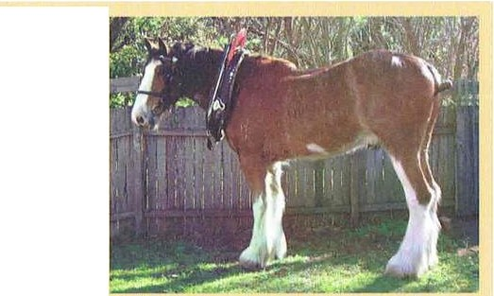
Draft Horses
A draft horse is a large horse bred for pulling heavy loads. Although machinery has largely replaced the work horse,the draft horse continues to hold a place of importance and tradition in
farming areas. Common breeds of
draft horses include the Belgian,

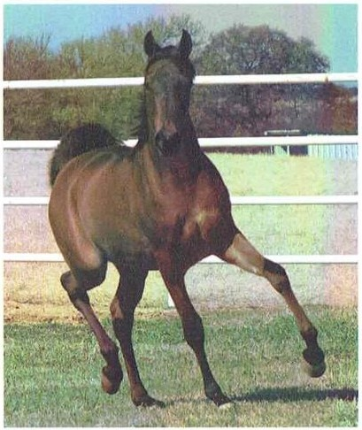
Arabians bond well with humans and are known for stamina, speed,intelligence, and grace.

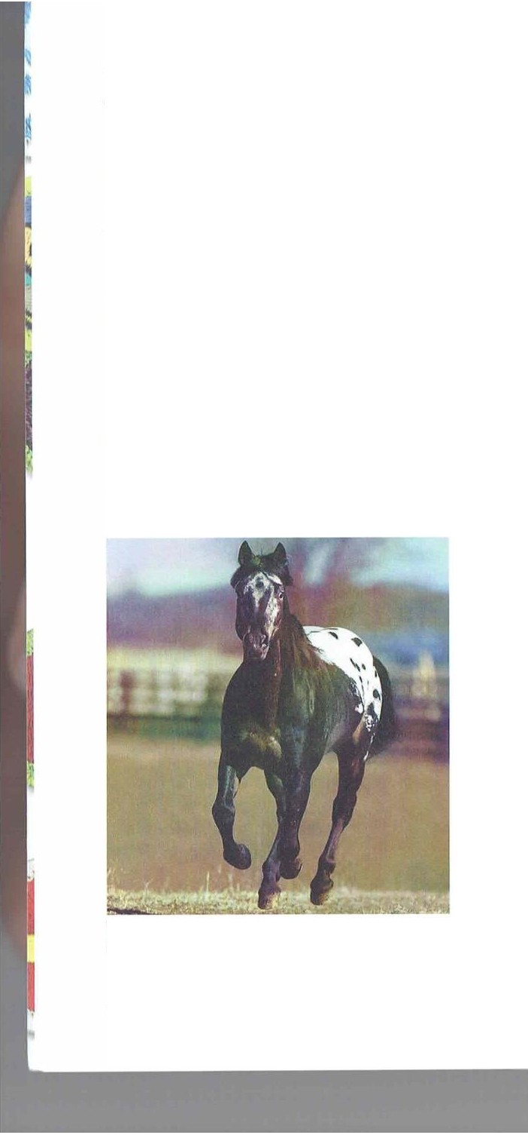

The Appaloosa has endurance,is athletic,and is easy to train.

16 HORSEMANSHIP
from 14.2 10 1 5.2 hands, but
European types can grow larger. Appaloosas are excellent to use
JS pleasure horses and in parades.
jump ing, reining, dressage, and gymkhana games.
Percheron, and Clydesdale. Draft Clydesdale horses weigh at least 1600 pounds
and stand at least 16 hands high.They have relatively deep, wide, strongly muscled bodies with strong backs and quarters. Their legs are short, and the leg bones are large and strong. Draft horses share the common traits of strength, patience, and a docile temperament, making them ideal for a multitude of purposes, including farming, show, and other recreational uses.
HORSEMANSHI P 17

UIOO\!Nl,A IIORSI- C11on INC A IIC)R\ [

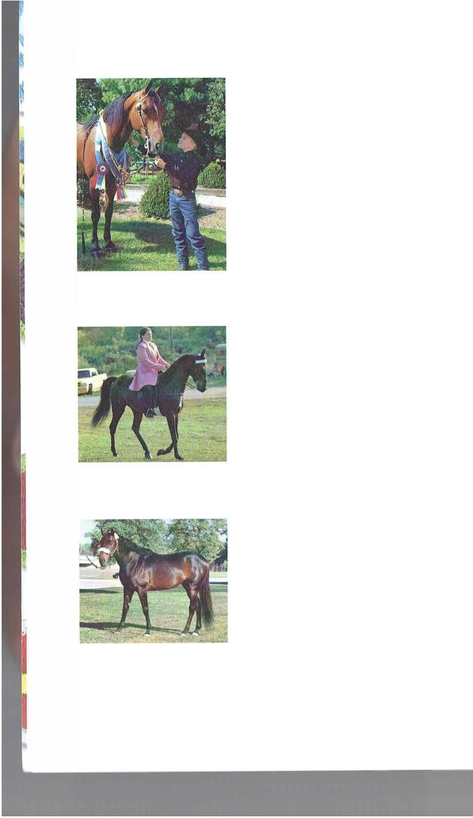

Morgans bond well with humans of all ages.Its traits include loyalty,tirelessness, reliability, and versatility.

The calm disposition and comfortable ride of the Tennessee walking horse make it very desirable.

Thoroughbreds were brought to the United States in the 18th century, and nearly all were bred for racing. Others were used as saddle horses and polo mounts.
18 HORSEMANSHP

Morgan
The Morgan was developed in the United States in t he lilte 18th and early 19th centuries from Lhc offspring of a horse named after it s owner, Justin Morgan.The Morgan is considered a general-purpose horse.
MorgilnS have small cars set above a broad fore­ head. They have large eyes, an arched neck, a broad chest, a short back, and compact bodies. The coat usually is reddish but can be brown or black. They are usually between 14 and IS hands tall. Morgans excel in many disciplines,including driving. carriage. park saddle, harness, hunter, dressage,cutting, com­ petit ive trail.pleasure saddle, reining,classic pleasure, and jumper.

Tennessee Walking Horse
The gilil 1ha1 m;ide a day"s work in t he saddle comfort­ able for Sout hern plantation owners continues lo be lhe best-known characterist ic of the cnnessee walking horse.-ibday, this docile horse is a favorite mount of park rangers, mounted police, field tra il enthusiasts, hunters, endurance riders.compelilive trail riders. and show-ring performers.It is famous for the running
walk that produces the unusual sliding ride that is so comfortable. The ' ennessee walker can cover as much as eight miles an hour at the wa lk instead or the four or five typical of other mounts.

Thoroughbred
Thoroughbred ancestry dates to three 17t h-century sires-the Darley Arab ian, the Codolphin Arab ian, and t he Byerley Turk. In England, offspring from these stallions were bred with stronger domestic horses, resulting in a horse that could carry weight with a sustained speed over longer distilnces.
Intelligent and courageous, thoroughbreds arc a popular choice in many disciplines, including hunt ing,ju mping and eventing. ilnd horse trials. Thoroughbreds usually are bet ween 16 and 16.2 hands. The head is lean, and veins can be seen underneath its thin skin. The a lert eyes are big and the nost rils are large. Principal colors are black,

brown, gray, chestnut .and bay. Thoroughbreds often are high-strung, nervous, and sensitive, and they can be temperamental.

Quarter Horse
The quarter horse was the first breed established and developed in the United States. It was developed from Spanish and Middle Eastern breeds that were crossed with horses from Engla nd and Ireland in the early 17th century. This combination result ed
in a compact, heavily muscled horse that excelled in short-distance racing.
The quarter horse often is used for ranch work. Because of it s ability to start,stop, and turn quickly, it is perfect for working cattle. II excels as a cutt ing horse, hunter, and pleasure horse. The quarter horse
stands between IS and 16 hands. and the usual color is chest nut.

Paint
The paint is descendecl from Spanish horses and is disti11guishecl by it s two-toned coat. Wit hin t he breed.
the coat patterns are divided loosely into three t ypes:tobiano, which is a mostly while coat with dark spots; overo, which is J most ly dark coat wit h white spots; and tovero, a combinat ion of tobiano and overo. American Indians liked the paint because its blotchy coat provided a nalural camouflage. Western cow­ boys liked it because ii could main­ t ain a comfortable pace over long distances. Paints stand bet ween 14
and 16 hands and have a w ide range of builds and temperaments.

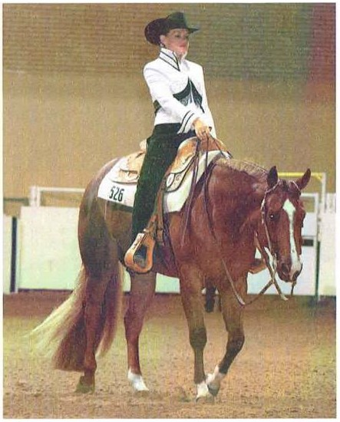
The quarter horse got its name from English settlers in the United States who raced them on quarter-mile stretches.

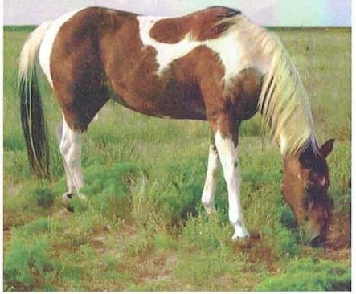
Paints can come in a variety of colors that generally fall into one of three coat patterns-tobiano,overo,or tovero.
HORSEMANSHIP 19

Cl IOOIN(, A IIOR\I'
(_ 1100\IN(, A llOll\l

Conformation too low. the horse is sway­

Co11{or111alio11 refers to a horse's build. It includes the horse's skelet;il ,111cl muscular struct ures and all of the physical features and proportions that are characterist ic of it s breed. A horse's conformat ion is a critical indicat ion of its soundness and ability. A well-proportioned horse will be well-balanced, which a llows it to move efficient ly and makes it less prone to unsoundness
and strain. A well-balanced conformation will give the horse ,1
longer working life and help it ma intain a better temper;iment.
/Is you choose your horse, keep t he follow ing things in mind.
First , look at the horse's
generalbuild. It should
backed. IIwell-aligned back and withers means a saddle will fit bett er.
Straight legs are impor­ tant for long-term soundness. Irregularities affect how the horse moves (which might affect its rideability) and may lead to unsoundness. View a horse from all sides to assess the legs.
When v iewing the forelegs
.ind hind legs from the front
!\ Ji
:( ..):
:\,AJ:

. . .
Proper front and hind
leg alignment,front and rear views

Proper front leg alignment, side view

be muscular and the mus­ cles should look evenly built,giv ing the horse a balanced shape.
Look for a well-shaped head that is proportional
to the rest of the body..11 head that is too big or sm.ill will upset the balance of the
Swaybacked horse horse's overa ll appearance.
Likew ise, the features of the face-the ears\ eyes. and nostrils-should be symmetrical and look pro­
portional to t he size of the head. The neck should be muscular, proportional to
the rest of the body, and slight ly arched.
The arch in t he back should clip slightly, and the
withers should be promi­
and behind. the alignment of each should follow a vertical line dropped from t he shoulder blades ancl buttocks through middle of the knees, hocks.
and fet locks to the center of
the hooves.
From the side, t he vert ica l alignment of the forelegs passes tbrough the center of knee,
cannon bone,and fetlock, and lands behind the heel. When view ing the hind legs from
the side, a line dropped from the point of the buttock to the ground should touch the hock and continue down t he vert ica l line formed by t he rear of the cannon bone and fetlock.
The illustrat ions here show some conformat ion faults you might see in a horse's legs:
!\ J!
:(

Bench-kneed­ the cannon bones are turned outward below the knee
!\ J i
:( -):

:w:
'

Knock-kneed­ the legs are curved inward at the knees

!\ l

:( ·1:
:vv:

Bowlegged ­ the hocks are positioned too far to the sides

Horse with normally curved back
nent, showing firm support for the neck muscles. In a mature horse, the croup will be aligned with the withers. If the Jrch in t he back dips
Cow-hocked- Splay-footed-the inwardly toes are turned turned hocks, outward below which can the fetlock
make the toes point outward
Sickle­ hocked­
excessively angled and weak hocks

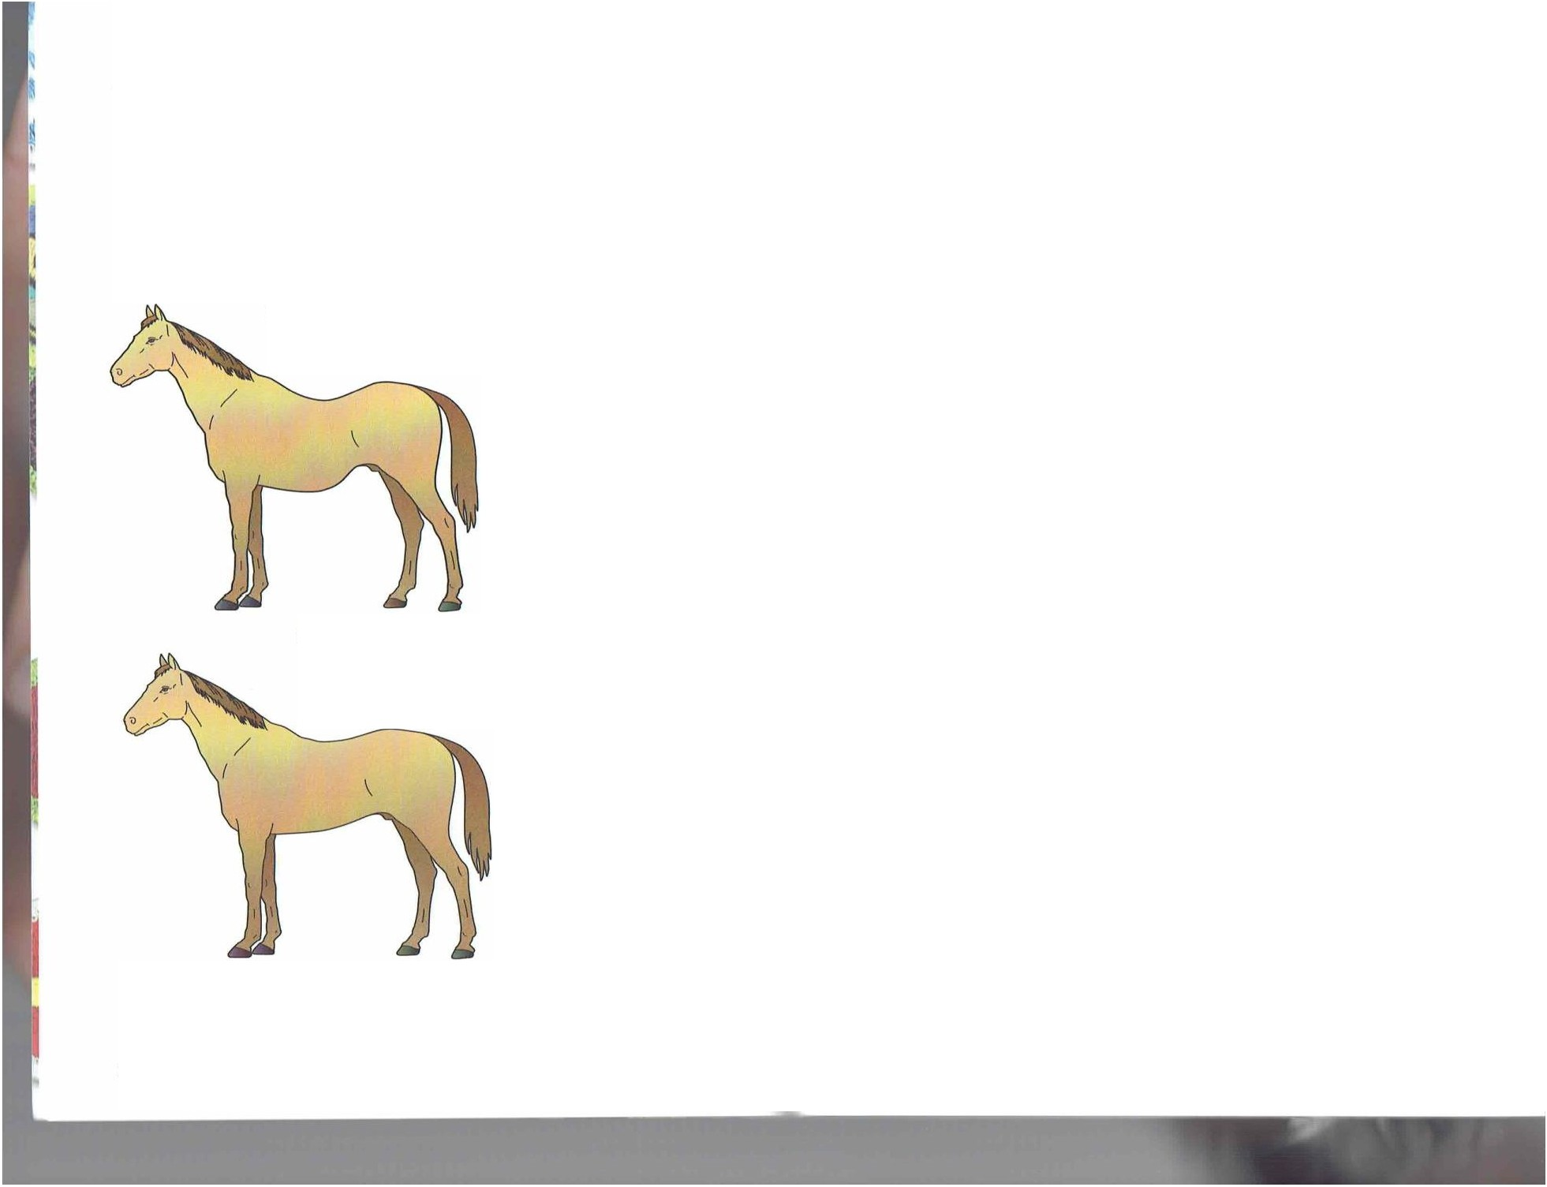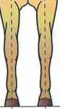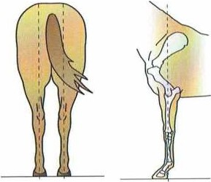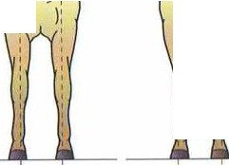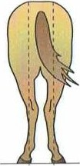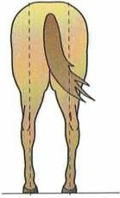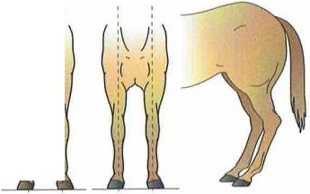
20 HORSEMANSHIP HORSEMANSHIP 21

( 1100\1NG A IIOR.\I -- CllllO\ INl, A IIOR\I

Age Considerations
A well-cared-for horse can be saddle-mounted for about 20 years. A n older horse that is a lready trained makes a better mount for a beginning rider t han a young, 1111lrained horse.

Sex, Disposition, and Soundness
Mares and geldings usually are the best choices for saddle horses. Geldings usually are calmer and steadier than mares or stallions. A mare might be more difficult to handle when she is in heat, which occurs for severa l days about once a mont h
throughout the spring, summer, and fall.

Beginning riders should start with a mature, trained horse. A begin­ ning rider should never consider mounting an untrained or unbroken horse. Stallions should never be chosen for young or novice riders.

Owning a Horse
If you keep a horse in a pasture, the generalrule is one horse per acre. A horse kept in a barn or stable will need bedding so that it does not stand on a hard surface constantly. Dust-free wood shav­ ings make a good, clean bedding. Itemp also can be used.
St ables and barns should be cleaneu every clay, sometimes more often. Remove all horse

Before you buy a horse, be sure you have a place to keep it. If you do not live on a farm or ranch, you will need to board the horse. Boarding rates will vary according to services provided.

waste and soiled bedding. Sweep and hose down t he floor. After t he floor is dry, add clean bedding.
You probably will need a way to t ransport your horse,
which means either buying or borrowing a horse trailer and having a vehicle that can pull the trailer.

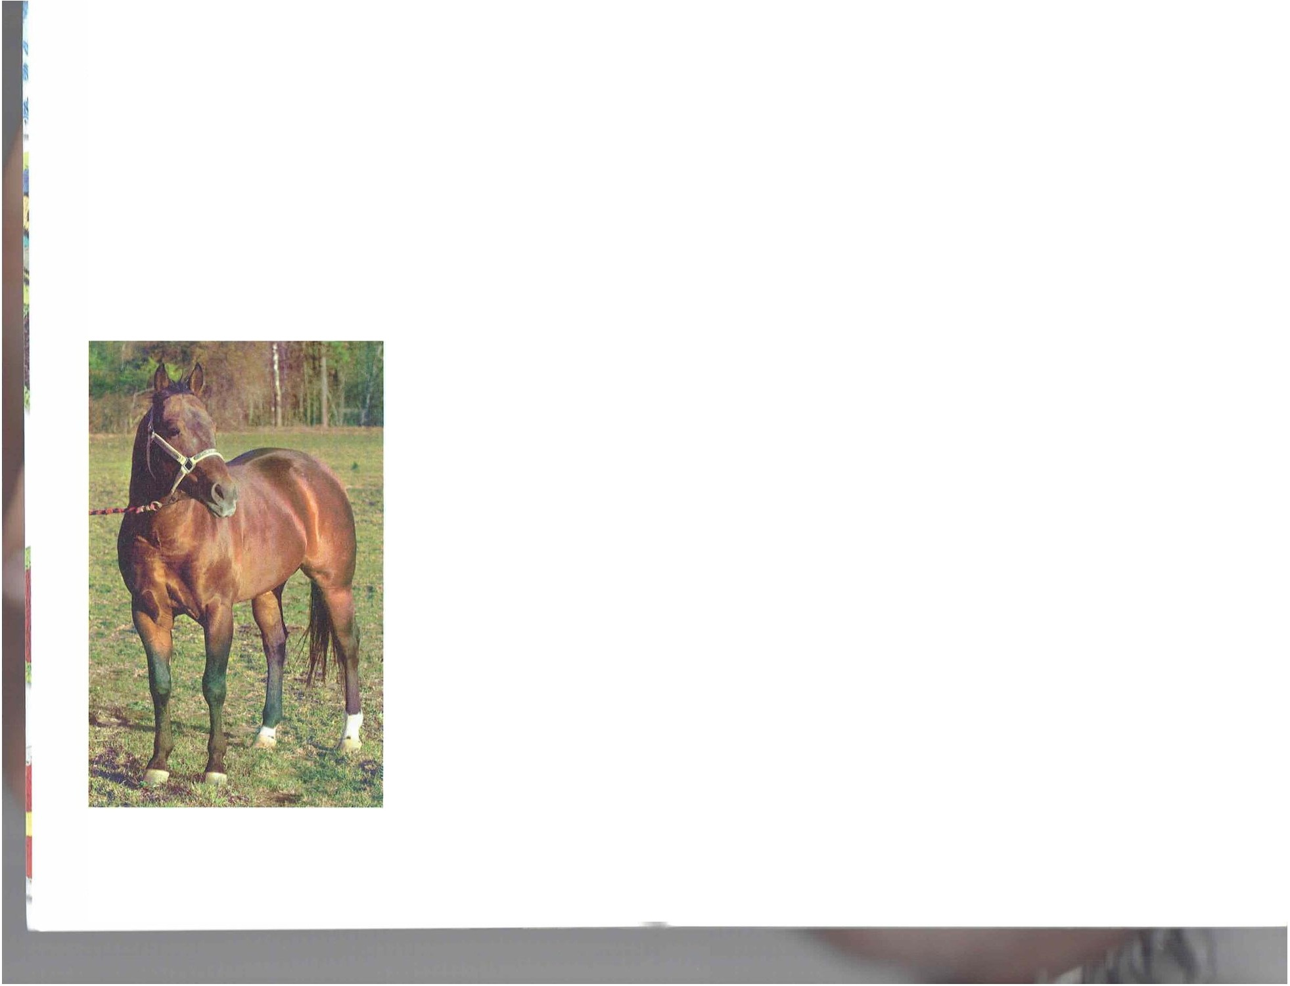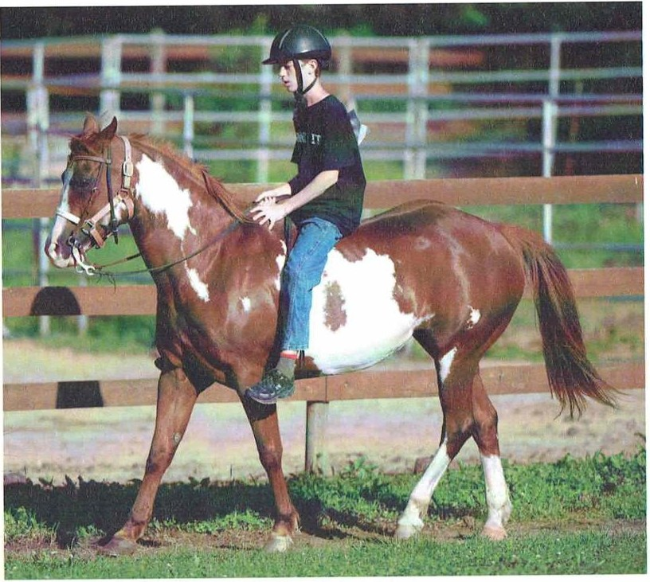22 HORSEMANSHIP
HORSEMANSHIP 23

CIIOOSINl, 11 IIORS I

Safety With Horses
Before you handle a horse,you should know a few safety rules. Because horses can sense if you are afraid, be confident yet carefularound them.
Prevent accidents and injuries by following these rules.
- Ground Safety
-Never startle a horse. Always speak reassuringly whenever you approach.
-While working around a horse, stay close to the front or sides so it will not be tempted to kick

- -- CIIOOSINC, II IIORSI

-Do not wrap the lead strap,halter rope, or reins around your hand, wrist,or body. Lead from the left or near side,using your right handto hold the lead rope. Keep the excess rope in the left hand in an S shape with your fingers to the outside.
-If the horse rears, release the hand nearest the halter so that you stay on the ground.
-Never mount in a barn or near fences,trees,or overhangs.A sidestepping horse could force you into one of these obstacles.
  - Riding Safety
-Never bind yourself to the horse or saddle.

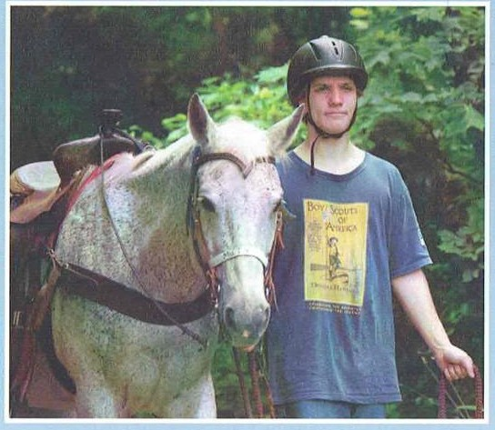

Facing the same direction as the horse,the near
side of the horse is on your / eh, and the off side is on your right.

24 HORSEMANSHIP
you and,if it does kick,you will not be struck with the full force of the kick.
-Never approach a horse directly from the rear because a horse has a blind spot directly behind it.You might startle it and cause it to kick,which could result in a serious injury.
-Walk beside your horse, near the shoulder, when leading it-never ahead or behind.
-Keep the horse under controland maintain a secure seat at alltimes.Horses are easily frightened by strange noises and objects.
-When a horse is frightened and attempts to run, turn it in a circle and tighten the circle until the horse stops.
-Hold your mount to a walk when going downhill or uphill.
-Slow down and hold the horse's head up when riding over rough ground or in sand, mud, ice, or snow,where there is a danger it might slip and fall.
-Avoid paved roads because a horse,especially one with shoes,can slip and fall.When you must cross a paved surface, slow the horse to a walk, or dismount and lead the horse across.
-Beginning riders should not jump a horse. If you cannot avoid a jump,give your horse a loose rein, grasp the saddle, and lean well forward with your heels down.
-If lost on a trail,allow the horse to go its own way.A horse knows where it is fed and, if given a choice, will return to that place.
Never ap1Jroac h
a horse from the rear or directly in front. These are blind spots for the horse.

HORSEMANSHIP 25

-.•. -- -- - - - i'A( K

Tack

You w ill need several pieces of tack. or equipment , lo ride and care for a horse. The cost of equipment can be high. "lb save money, you might buy used tack t hat has been well-maintained. Whatever you buy, the tack must fit the horse. Learning 10 properly use;rnd take care of equipment is important.

Saddles
The type of s11ddle you get will depend on your reason for riding t he horse. Dist inctive styles of Western and English saddles are available for dressage, show ju mping, Western pleasure, rnd saddle seat classes. You might choose an English general-purpose saddle or a Western t rail sadd le because bot h can be used for sevcrJI activities.
Saddles are made of leat her or a synt het ic material.
Quality le,1ther saddles arc supple, strong, long-last ing, and cost ly. Synthetic saddles usually are less expensive and easier to maintain, but they might not he as dur11hle.

Tack includes saddles, bridles, harnesses,and other equipment you use for riding or leading a horse.

Western saddle

HORN I-ORK f'OMMEL
JOCKEY
FENDER
LAflGO

CANTLE (WllH CH[YENNE ROLL)

-CONCIIOS SKIRT

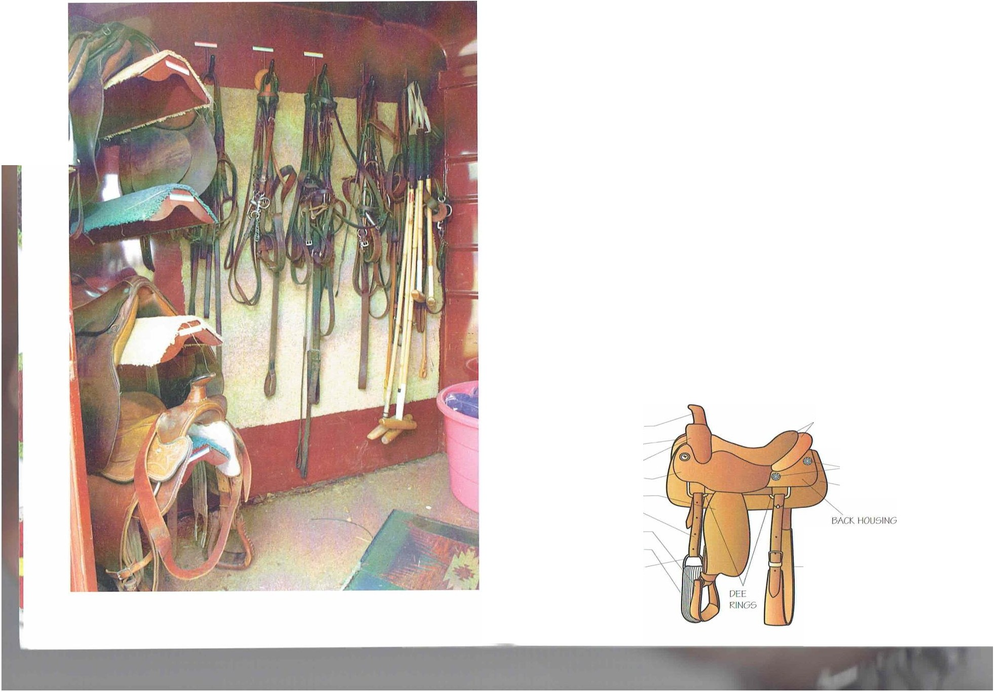
STIRRUf' CINCH
CINCIIRING - FLANK CINCI l

HORSEMANSHIP 27

lM K
- - - - - TAl f..

English saddle

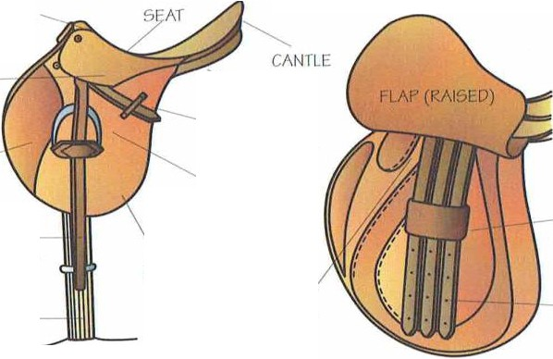
POMMEL

SKIRT

PANFL

The main interior supporl of the saddle is called the lree.
It can be made of wood or a hard synthetic material and is covered with leat her or synthetic material. The girth or cinch is a str.ip of leather,cotton,woo l.or synthetic material and is used to secure t he saddle to the horse. f'laps, skirts,and fenders
protect t he horse's sides and t he rider's legs.

Bridles

KNEC. ROLL
STIRRUP LOOI' The rider uses the bridle and reins to tell the horse where
to go. stop, or t urn. Pulling or guiding the reins pulls on the

STIRRUP LEAOltR

rLAP
SflRRUP
(OR IRON) BUCKLE
GUARD
bit and the bar in t he horse's mouth. which applies pressure to the horse's tongue.

GIRTH
POINT POCKET
GIRTH STRAPS

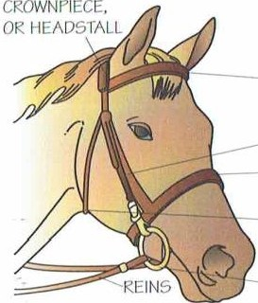
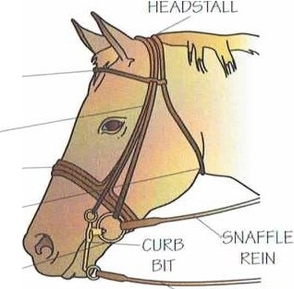
BROWBAND

An ill-fitting or poorly adjusted saddle will
make the horse's back sore.
English and Western saddles have distinct differences. The Western saddle was designed for driving cattle a nd is also called a stock saddle. It has a higher cr,nt lc (the raised back part), a higher pommel (the raised front part). ,rnd longer stirrup leathers than the English saddle. The Western saddle also has a saddle horn. for tying and carrying rope to lasso cattle. 1
The heavier and larger Western saddle might give a
beginner more security. but it is harder to handle than an English saddle, which is lighter and flatt er and requires that the rider develop a surer seat, which can lead to better horsemanship. On an English saddle, t he rider sits closer
to t he horse, which allows the rider to more easily use posture and leg movement to communicate to t he horse.

Consider the size and shape of the horse when fitting a saddle. Have an experienced horseman check the fit of the tack on the horse to make sure the saddle does not slip, rock from side to side, or pinch the horse's withers.
CHEEKPIECE NOSEBA ND

THRO/\ILATCH

SNAFrLE BIT

Single rein Double rein

Bridle types include the single, double, and hackamore.
However, only experienced riders should use the double
and hackamore bridles. Parts of the bridle can include the headstall. browband, t hroatlatch, noseband, cheek piece.bit, and reins.
When positioning the bridle, it is recommended that
t wo fingers fit under the browband and the noseba nd. The browband should allow the headstall to rest comfortably behind the ears, just below the base of t he ears.The other parts of the bridle can be adjusted to fit.
Full check snaffles are common bits used in both Western and English riding. The ordinary single-jointed snaffle bits should be fitted wit h about l/4 inch clearance between the horse's lips Jnd the bit ring. Double-jointed bits are fitted more closely to the width of t he horse's mouth.

CURB REIN

28 HORSEMANSHIP
HORSEMANSHIP 29

IA( "-- - - · - - - -
_ IA( t.:

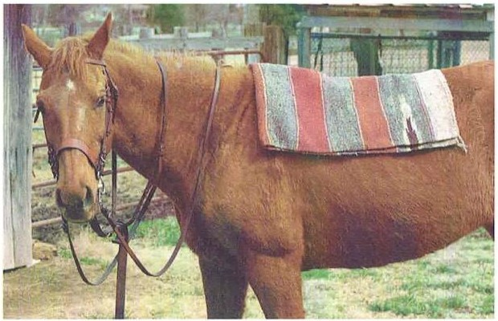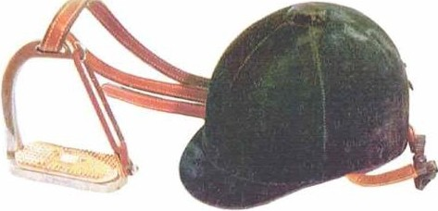

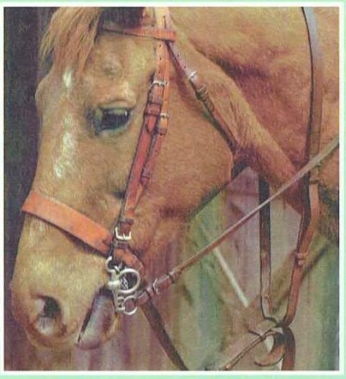
The bit should be placed in the toothless gap between the front and back teeth.
A correctly adjusted bit should cause only one or two wrinkles in the corner of the horse's mouth.
However, this might not be appropriate with horses that have an unusually
long or short mouth. A
bit that suspends too low will bang against the front teeth. A bit that is pulled too high will press against the molars.

Saddle Pads and Blankets
The saddle pad, or numnah, adds comfon when t he horse is wearing a saddle. When fitt ing the pad on t he horse's saddle area, be sure to slide it in the same direct ion t hat t he horse's
hair grows. The pad should not be creased or wrinkled any­ where. and it should be pulled up fully into the saddle gullet.

30 HORSEMANSHIP

Clothing
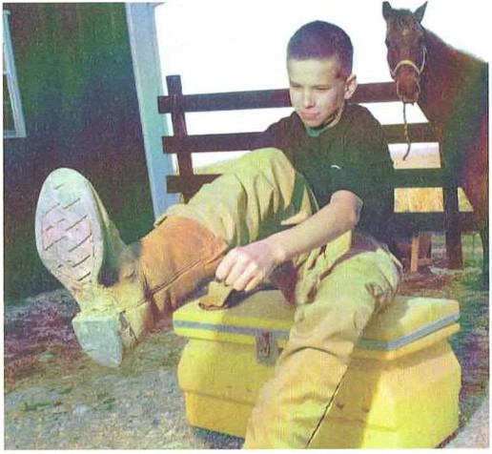
When you lea rn to ride, wear clothes that are comfortable and will not impede riding.
That can include jea ns or jodhpurs (breeches that are worn in English riding).
Gloves will keep your hands clean, prevent blisters, and give you a better grip on the reins. Western boots, long riding boots.or jodhpur boots are recommended. You should not wear flexible. light shoes or heavy hiking boots.
In certain terrain. shoes with cleats add traction.

Safety Stirrups and Helmets
Ilorse riding can be dangerous. so take precautions t o ride safely. f-irst, make sure you have proper-fitting tack to help
avoid causing the horse to 1Jeco111e irrit ated and hard to control.
A proper riding helmet is very important. Only helmets approved for equestrian activit ies (such as one approved for horseback riding by the ASTM) should be used. Ilclmets designed for other sports will not give you t he necessary level of protection.

Wear an equestrian helmet to help prevent head injuries that could be caused by falling from a horse or being kicked.Consider using safety stinups to ensure that your foot does not get trapped in the stinup if you fall.
Be sure the stinups fit your footwear.Use stinups that are .to 'lo inch wider than the footwear.

When participating in Scouting-related horsemanship activ­ ities that call for you to work directly with or around a horse,you should wear an equestrian helmet approved by ASTIand ANSI.

HORSEMANSHIP 31

IAl.K It\l "
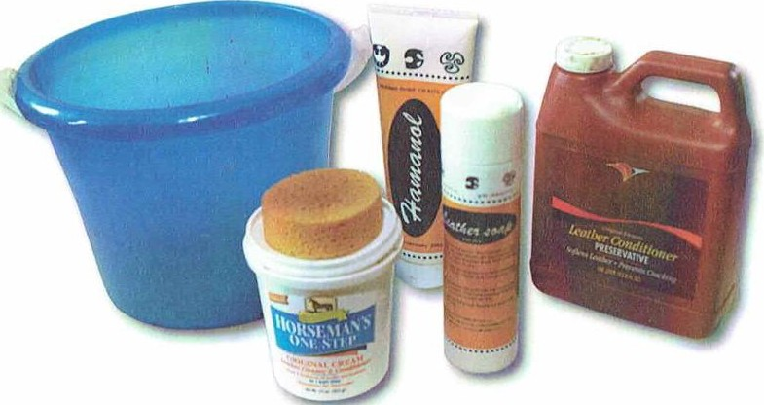
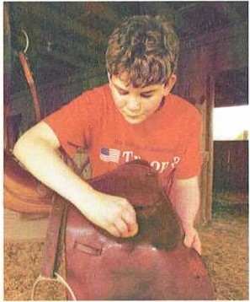
·1b properly clean. strip the saddle of the girt h and
st irrup leathers and. on English
saddles, remove t he st irrup irons. Using a clamp washing sponge, wipe off dirt or any mud on the saddle and parts you have removed. Do not for­ get t he underside of the saddle.

Care of Equipment
Your safety and the horsc·s comfort depend on tack that is clean and in good condition. To take care of tack properly, you w ill need these items:
Use a chamois to help d1y the tack. After the tack dries, rub a sponge wit h wet saddle soap and sponge the soap into the saddle using a circular motion. The sponge should be only slightly clamp so that the soap docs not lather.
Re-soap the sponge often. Be

......
-II

- Saddle soap
- Multiple sponges, for washing and soaping
- Chamois cloth
- Leather conditioner such as neat 's- foot oil
- Metal polish
- Cheesecloth
- Clean towels
- A blunt knife
- A st iff toothbrush
- A straight st ick to poke excess soap out of'buckle holes, etc.
- A saddle rack to hold the saddle
- A bridle rack
sure to soap underneath t he
flaps, then soap the st irrup leathers, and ot her lea thers. Clean the Western saddle stirrups, which often arc covered in raw­ hide. Wipe off excess soap with a clamp clot h. You can oil the leather parts on occasion,but use oil sparingly.
If you have a fabric girth, it can be scrubbed with a mild detergent. Rinse off the soap thoroughly and prevent rust by immediately drying and polishing the metal billet buckles or cinch ring.
Use metal polish on the metal parts. But do not put polish
on the mouthpiece or wash it with soap. Wash the mouthpiece occas ionally with warm water. Keep saddle blankets and pacts clean, dry, and well-aired.

Clean the tack after each ride,especially the leather parts. If you cannot do a complete cleaning, at least clean under the saddle and wipe the reins clean using a damp sponge.

Store tack properly, such as in a well-ventilated storage shed-not in places such as a car trunk or dusty barn. Hang up the bridle, and put the saddle on a saddle rack or saddle horse.

32 HORSEMANSHIP
HORSEMANSHIP 33

<iROOMINl;AN() CARI

Grooming and Care
Proper grooming of your horse is importa nt. Dirty coats CJn lead to fungus and other skin problems. Grooming gives you
a chance to look for parasites and wounds. Plus, grooming w ill give you a sleek, good-looking horse.
Outdoor horses do not need to be bat hed as often as
stabled horses because outdoor horses need to build up more naturalbody grease for protection against the weather. Also, outdoor horses will roll in the grass or dirt to help stimulate
t heir skin.
Grooming equipment you w ill need:

Aside from being a necessary task, grooming allows you to communicate
and build a closer relationship with your horse. Ta lk kindly and softly to your horse while grooming.

BODY BRUSII

DANDY Bf'.USH

GROOMING
SHEARS MANL AND fAIL COMBS

FARPl[R'S HOOF KNIFE-

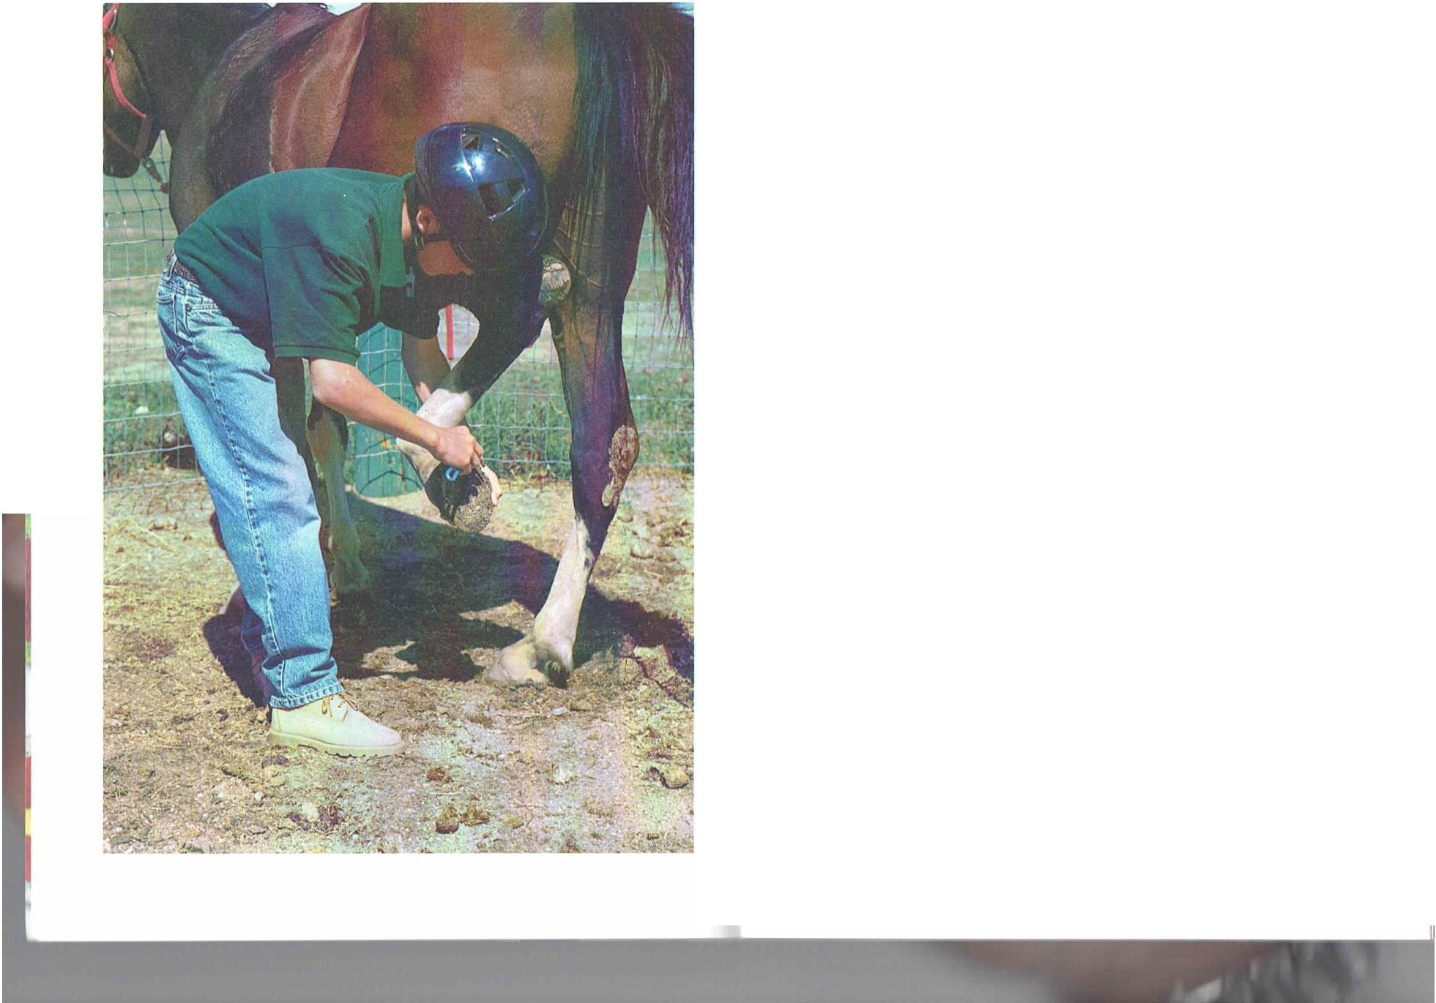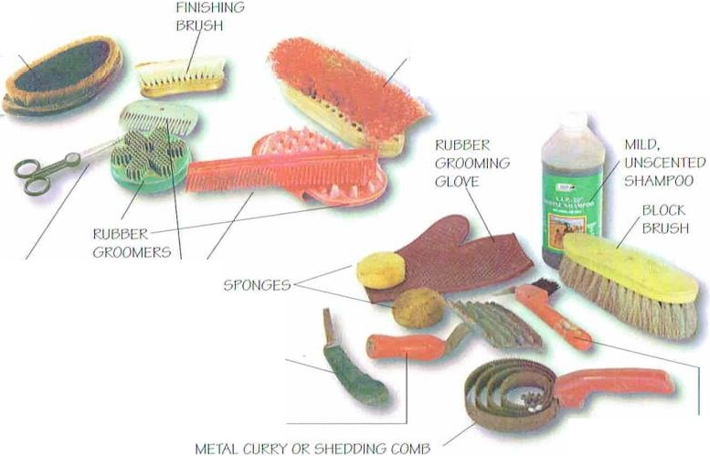51lrDDING CDMl3

If t he horse has caked and dried mud or dirt on it, use the dandy brush to remove t he dirt by working in t he direction of hair growth. Wash off wet mud. or wait unt il it dries to brush it off.

HOOF PICK AND BRUSH COMBO

HORSEMANSHIP 35

CROOM IN(, ANJl ( ARI
(;ROOM IN(,,\Nil CARI

Before grooming, tie the horse in a safe place inside a stable or outside, using a quick-release knot like the one shown here.This knot enables you to release the horse quickly in case of emergency. Be sure the tie is levelwith, or slightly higher than, the horse's wither.
Step 1 -Tie the free end of the horse's lead rope to a breakaway
tie-a piece of string, baling twine, or leather.Then, tie the breakaway tie around a post or through a ring.
Step 2-Create a loop by bringing the free end over and around the tie end (the part of the rope attached to the horse).
Step 3-Make another loop with the free end,and push this loop through the one you made in step 2.
Step 4-Pull the tip of this loop to tighten the knot.
To undo the knot in case of an emergency, pull the free end.

Next , wit h t he body brush in one hand. work from the front of the horse toward the rear. Work the brush in the direction in which the hair grows. I!ere are some other grooming t ips.
- Take care not to bang t he hard edges of the body brush against bony areas.
I
- Keep the hand t hat is not brushing in contact with t he horse. Doing so helps lo quiet the horse. II will also wa rn you of any dangerous movement the horse may make.

  - Use a soft brush or t he body brush to gently brush over the eyes and cars.
  - After every few strokes. clean your brush with the metJI currycomb.
  - Keep a routine of the areas brushed, starting with the near side, or left side. so that you do not miss an area. Brush
firmly, but do not be too rough.
  - Use t he borly brush on t he m1111e, forelock. and tail. Brush gently. working t hrough a few hairs 11t a time to 11void breaking t he hJirs. Use your fingers to untangle any knots while holding t he hair in t he other hand. After brushing, you can lay out t he mane and tail using a clamp brush to help keep the hair in place.
  - Pull long, unwanted hairs from t he mane rJther thJn cut ihe mane.
  - Brush t he forelegs. paying special att ent ion to lhe joi nt areas and t he area behind the pasterns. Do not use a currycomb below the horse's knees.
  - W ith a clamp sponge. clean the dirt and discharges from t he nose, lips, and eyes. With a different sponge. clean the rear, lhe tail, and, if you have a gelding, t he sheat h. Wash the sponges thoroughly after using them.
  - I\ final polish is next. Use a dampened soft cloth or a chamois to smooth down the whole horse.

Some horses might be ticklish between the hind legs and on the belly.You might need to use your hand to brush these areas.

Normally,you should not comb or brush the tail on a regular basis.
Doing so can break the hair or pull it out. Over time, this would result in a sparse, thin tail.

Remember,horses have blind spots directly in front of and behind them.

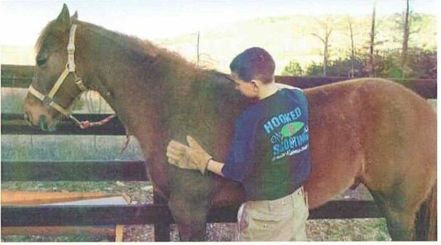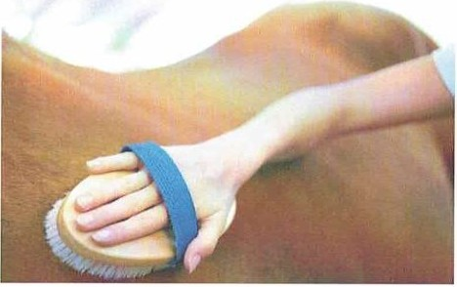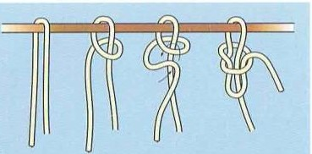36 HORSEMA NSHIP
HORSEMANSHIP 37

(;ROOll·IINC A N ll ( A lli

Hoof Care
A horse's usefulness depends greatly on the condition of its hooves, which neecl daily inspection and attention to s1ay heallhy.
For example, rocks and 01her objects can loclge in the hooves ancl cause bruising.
In addi1ion, long-t erm exposure to bacteria can lead to infections.
Ilooves grow cont inuously. StJrting
when a horse is about 6 week s old, the hooves should be leveled with a rasp (file)
to prevent the bones from growing crooked. Lifling, inspect ing, ancl cleaning the hooves

Horse's hoof

BA R

- CltllOM I Nl; i\ N ll CA IU

BULBS
rROG

llrEL

C[NTRAL
GROOVr or
FROG

daily w ill prepare the horse for 1he possible next step of shoeing.
COLLATl:RAL GROOVE

WIIITE LINE

SOLE
WAI.I.

BAR OF WALi

A hoof pick probably will be the most important item in your grooming kit. Always clean the hooves before and after riding.

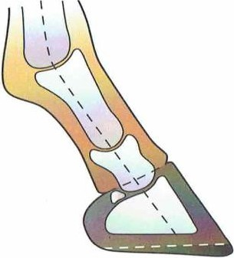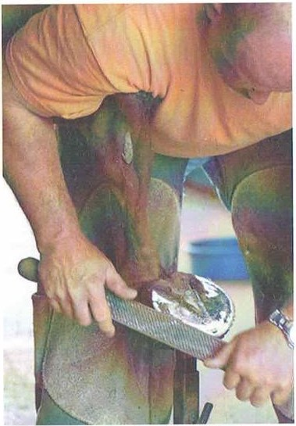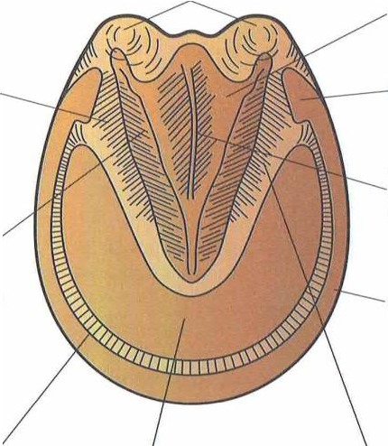

Use the hoof pick to carefully clean the bottom of each hoof from heelto toe. Clean with the point working away from you.

38 HORSEMANSHIP

Rasping and shoeing should be done only by a farrier.

'.J
Most horses arc first shod at about age 2. Shoes help prevent excessive hoof wear under rocky conditions. llorses with shoes need a hoof trim and reshoeing itbout every six 10 eight weeks.
Ilorses wit h conformation faulls can be helped by proper shoeing.A horse 1ha1 has fla t soles or weak hoof walls probably will need shoes. Shoes can protect the hooves from objects, such as stones. Itorses that are ridden in the w int er. when the foot ing can be slippery, will need the added traction 1hat shoes provide. Special cleats also can be used to enhance fooling under certain conditions.
It is best to keep horses out of wet. muddy areas because these condit ions can promote fungal infections. Besides thrush and founder. which arc discussed l1t cr in t his pamphlet ,ot her problems with hooves include corns. bruised soles. abscesses. cracks. splitt ing, and nav icular disease.

HORSEMANSHIP 39

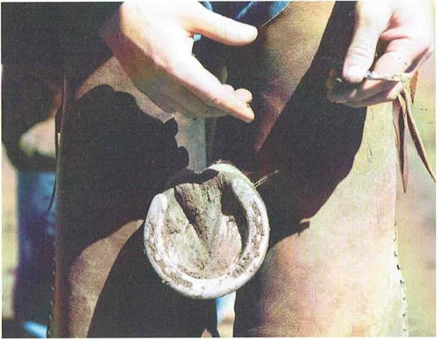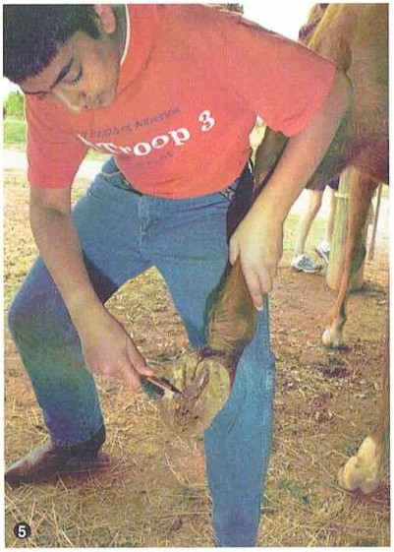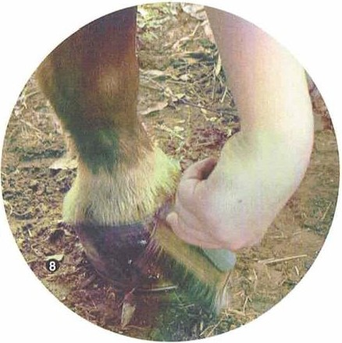

(iltO()MIN(, i\Nll ( •\RI

Steps for Picking Hooves
Ilcrc arc t he steps 10 help you care for the hooves.
Step 1-Put a halter on the horse and lie it to a rail or post w ilh a quick-release knol. Make sure t he horse is slantling square with ils weight evenly distribulecl.
Step 2-Stancl beside the horse's left foreleg, facing lowarcl the Lail. Run your left hand clown 1he leg so the horse is aware Lhal you are going lo do somelhing. Many horses will lift t he foot when the hand reaches the pastern (just below the fetlock joint a ml above the hoof).
Step 3-lf t he horse does not lift ils fool, apply gent le pressure with your t humb and foref nger to either side of the fetlock, or firmly pinch the pastern with your thumb and index finger.
Step 4-lf your horse still does not pick up its fool,lean against the horse sligh1ly, pushing it s weigh1 Lo the ot her fore­ leg while trying steps 2 and 3 again.

A professionalshoer at work

A shod horse's hooves should be picked daily,This will give you a chance to check for infections, foreign objects, loose shoes, and other problems.

40 HORSEMANSHIP

Step 5-0ncc the horse lifts the leg, hold it in your left hand. I!old the hoof pick in your right hand, and begin cleaning from heel LO toe to remove debris. Pay paniculM,1llenlion to cleaning t he cleft between 1hc sole and the frog. Check for dampness and any dark, foul-smelling fluid oozing from the frog or sole. The frog should be firm, with no discharge.If you find problems, have a veterinarian examine the horse.
Step 6-Chcck the shoes for loose or missing nails. Make sure nails arc crimped clown so they do not pull out.
Step 7-Repeat steps I through 6 with 1he remaining three hooves, working in order from the near hind foot , t he
far (right) forefoot, and the right hind foot. To pick up a horse's hind foot, stand beside the horse's flank. Place a hand on t he horse's hip and run your other hand down the leg to the cannon. Pull the leg forward, binding it to the hock. Walk straight back, resting t he horse·s cannon on your
thigh. Lock your arm over the hock so that the horse cannot kick.
Step 8-Use a paintbrush to apply a hoof dressi ng, especially if the
hooves arc dry and brittle. Work from
the inside of t he hoof lo the outside.

(;RO(),\\IN<; AND Ci\tU

HORSEMANSHIP 41

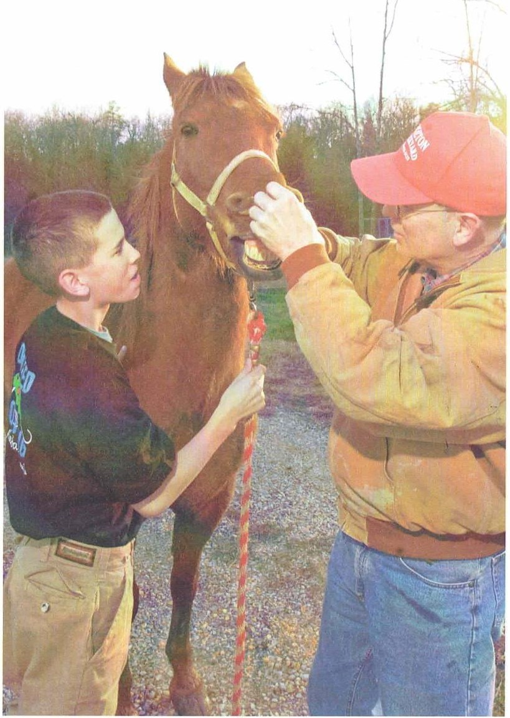
Health Matters

IIIAl 1 11 MAI llll\

I\ heallhy horse has brigh1 eyes. and the membranes under the eyelids and nostrilarc an even, pink color. I\ healthy horse's coal lays fla t and has a glossy sheen. The skin should be de. n and loose. The limbs should not have swelling.
/\ 11 unheallhy horse could have many of the following signs:

- Red, yellow, while, or purple membranes under the eyes or in the nost rils
- A t ight. blot chy coal
- Puffiness in the limbs
- Loss of appetite
- A cough. runny nose. or Wiltery eyes
  - A bnormal
bowel movement s
  - Strong-smelling manure
  - Thick and dark urine
  - I\ protruding bone structure
  - IIigh 1e111pe ralllre
  - Uneasiness or restlessness
  - Sweating while al rcsl

If your horse displays any unheallhy conditions, consull a vet erinarian.

A horse's normal temperatu re is between 100 to 101.5 degrees. The normal pulse rate is 32 to 44 beats per minute. A horse at rest will have respiration of eight to 15 breaths a minute.The temperature is taken professionally using a rectal thermometer. The pulse can be taken by feeling the inner surface of the lower jaw, just behind the elbow and the eye. Count the pulse for 20 seconds on a stopwatch, then multiply
by three.

HORSEMANSHIP 43

1 11 Al I 11 1\\1\ I 11 R

Keep a calendar and mark each time that your horse has been shod, vaccinated, and dewormed,
and when its hooves have been trimmed and its teeth rasped.

Regular Checkups
Besides hav ing your horse exa mined by ,1 velerinaria n when it is ill or lame. your horse also needs regular checkups. !'or
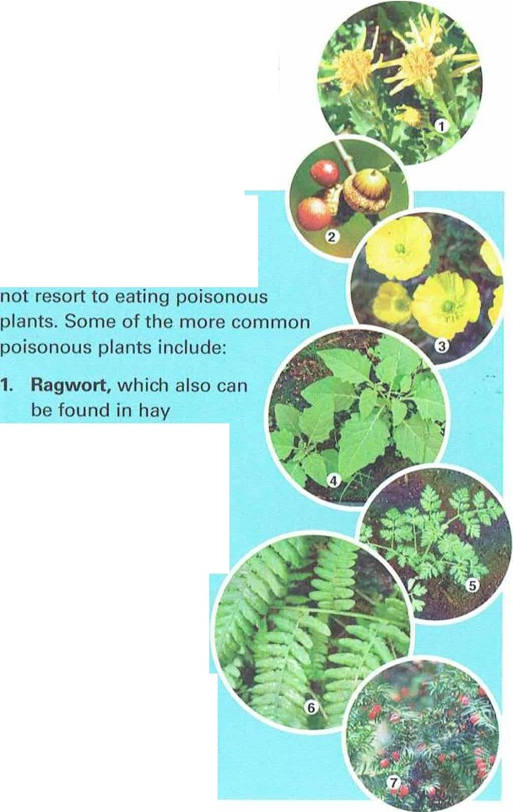
cxJ 111ple,a horse needs vJccina1ions 10 prevenlserious diseJses such as 1e1anus and equine flu . /\II horses should be wormed on a regulM basis. /\ horsr·s teet h should be checked once a year. Older horses might need more frequenl leet h checkups.

Dangerous Plants
If your horse grazes in past ures and fields,you w ill need 10 be aware of t he poisonous plants in your area. Check with a veterinarian or horse expert to lea rn more.

Make sure that horses on pasture have adequate hay
and/or grass so that they will

- Acorns, when eaten in large quantities

First Aid
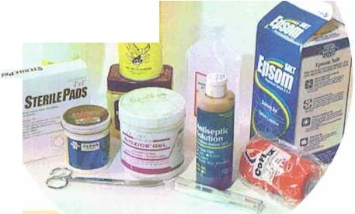You will need a firsl-Jid kit to tend l
o minor scra 1chcs
ust be
rse
s
..
• ·., 11<;lt"I
, .,,.,,-
and wounds./\ny serious inju ries m lrea led by a vc lerinMia n. If your ho is wounded.la ke t he follow ing step while waiting for the veterinari,111:
- Calm the horse by talking in .1 soot hing voice and stroking, patting, and rubbing the horse gently,quietly,and slowly.
- Slow lhe bleeding if necessary, confine the horse.1hen cle n and disinfect the wound.
- Do not attempt to 1reat eye. joint, or deep abdominalwounds.

A first-aid kit prepared specially for your horse (with a veterinarian's advice,
if necessary) will ensure that you have the right materials available in case of an emergency. Store the first-aid items in a sealable plastic container and keep the container where you can reach it easily, such as the tack room.
First-aid kits for horses should include most of the following items:

IIIAl 1 11 MA I 1 1 R\

- Buttercups

- Nightshade

- Hemlock
- Bracken fem

- Yew trees are extremely toxic, and all parts of the
tree, whether dead or living, are poisonous.
- Disinfectant
(rubbing alcohol)
- Antiseptic ointment
- Antibiotic ointment
- Swabs
- Sterile gauze sponges or pads (a variety of sizes)
- 3-inch gauze roll
- Adhesive tape (2-inch rolls)
- Safety pins
  - Instant ice pack
  - Scissors
  - Tweezers or forceps to remove thorns or splinters
  - Fly repellant
  - Horse thermometer
  - Petroleum jelly
  - Epsom salts, for soaking abscessed feet

44 HORSEMANSHIP HORSEMANSHIP 45

lt l td Il l i\11\ l l l R\

lb slow or stop the bleeding. place a pressure pad on 1he wound ;ind apply a bandage over lhal. You might have to hold it in position. Ilosing a fresh wound will delay dolling: however, a quick ligh1 hosing to eliminale dirlor foreign
objects mighl be necessa ry. You also can clean the wound by gently swabbing it or flushing it with a mild disinfcctanl.

Ailments
Keeping your horse and slablc clean will help prevent many of !he ailmcnls Iha!can afflict a horse. l<eep feed boxes and bedding clean, as well. Make sure your horse has access lo clean, fresh wa ter at all limes.
The following common horse-related,1ilmen1s require immediate cxaminalion by a veterinarian.
Colic is pain in lhe abdomen. Colic can be mild or seri­
ous enoughlo cause dealh.Some of t he causes include moldy feeds. int ernal parasites. overfeeding on grain when !he horse is t ired. lelling a horse gorge 011 reed while it is s!ill hot after a workout, or riding a horse immedia tely after a full feeding.
I\ horse wilh colic is in greal pain. The horse will be agitaled.constantly moving. swealing,and trying to roll. Rolling can be dangerous because it could cause a lwisled in1esline, which requires emergency surgery. llaller an afflict ed horse to keep it from rolling. Wa lk !he horse unlil the veterinarian a rrives.
Founder, or la minitis. is an inflammalion of !he sensitive
!issue in a horse's hoof that usua lly causes lameness. I! is one of !he mos! serious hoof diseases. I\ gap forms between !he hoof and the sole. pushing !he coffin join! out of position.This condition causes severe pain w hen t he horse puls weigh! on
!he a ffccled fool.
One common cause is lclling a horse cat in lush grasses. Ilorscs arc not able to cope w it h large amounls of lush spring grass or feed mixes !ha t are rich in protein.
Parasites such as roundworms. stomach worms, blood­ worms, or bots (botfly lar vae) can infect a horse. /\ n inrectcd horse mighlsurfer from poor growth,anemia. a dull coa l, listlessness, and digeslive problems. Strongyloidcs (types of parasit e worms) can damage abdominal aneries. Roundworms can cause problems for young horses and yearlings. Colts and fillies oflen suffer from pinworms, which cause severe ilching around t he tail.

In addit ion to giving an afflicled horse cleworming drugs. regularly clean and remove manure from stables or indoor
a reas where t he horse is kept. Do not dispose of t he ma nure in pastures or near water or feed. Ilave a ve1erinaria n screen lhe horse's manure for parasites a couple of t imes J year and 1wo weeks after deworming.
Respiratory problems and coughing also arc common horse ailments. /\ n a fflict ed horse w ill cough and/or w heeze because of irritation in !he airway. This could be caused or aggravated by dusty, moldy feed; fungal spores in hay ; or being ridden in cold air.
Strangles,or equine distemper, is a fa irly common, contagious disease that st ems from an infection caused by Streptococcus equi bJcleria. Young horses bet ween 6 monlhs a nd 5 years of age and very old horses are most susceptible 10 the disease.
Symptoms can be swollen lymph nodes in the head
and neck regions. nasal disc harge. lack of appet ite, and high fever. Isolate any horses showing these symploms in a clean. well-ventila led sli.l ll.
EPM, or equine protozoa! myeloencephali1is.is a debili­ tating neurological disorder caused by a parasite that enters
t he horse t hrough infect ed drinking water or food and selllcs in the spinal cord. Symptoms include lameness.wea kness. loss of motor con1rol. loss of appetite. muscle atrophy ( loss
of muscle). ancl paralysis. ·rest s cannot prove conclusively if a horse has EPM.
Mos!experts believe that t he source of t he pJr,1sit e is opossum droppings. To help prevent the disease, protect wat er and feed from opossums, conduct proper grooming routines,
and minimize stress 10 the horse.
Equine infectious anemia, also called swamp fever. is t ransmitted by biling fl ies a nd mosquitoes. The ailmcnl attacks a horse's immune system, and t here is no vaccine.
Symptoms include high fever.no appet ile, labored breat h­ ing, pounding heartbeat . bleeding in the mouih. and leg swell­ ing. Because t his is a viral disease. no drugs can effeclively 1rcat ii. Infected horses usually die within 30 clays.
Moon blindness, or periodic ophthalmia . is t he most common cause of blindness in horses. Not much is known about the condilion.w hich causes an inflammation or the blood vessels i11 t he eye. It usuc1lly c1frects only one eye and
111 A t 111 MI\ I II llS

46 HORSEMANSHIP HORSEMANSHIP 47

IIf A Ir11 MA fl ll!,
------ --- --- - ---- -- IIIAI III MAI ll'R\

Some peo11le believe the recurrence of moon blindness coincides with the phases of the moon.thus the name.
often recurs. Thoroughbreds 2 10 3 years old arc the most com­ monly affected.but horses of any age can become afflicted.
Symptoms include redness, increased tearing. half-closed. and painful-looking eyes. as well as swelling anti tenderness of Ihe eye or eyes.
Monday morning disease, or azoturia. is most oft en not iced when a horse has worked hard during t he week wltile
on full feed but gets sick when put to work on Mond;iy (or any clay) aftt't' a period of idleness during which t he horse continued to receive full feeo. Though eat ing too much while idle is the cause. azoturia is regarded as a more complex issue, involving type of diet . vitamin deficiencies. and ot her factors.
When being worked or exercised again a ft er the idleness.
t he loins and quarters st iffen and cramps result. Other symptoms might include a high temperature, swc,11ing,and st iffening of
t he legs.
Common unsoundness is linked to a horse's confor ma­ t ion and includes anything t hat inhibits or interferes w ith the horse's st rong. natural inst inct s or tha t affects t he intended use of a horse.
Lameness is t he impaired movement of t he legs. A horse generally is considered lame when pain causes it to alter t he usual weight distribution on one or more legs. Lameness ca n be caused from:
- Inherited conformat ion faults
- Bruised soles
- Cracked or badly t rimmed hooves
- Tendon. liga ment , or joint problems
- A sore back

Problems of Unsoundness
Splints are swellings and bony enlargements on the splint bones, which are small bones located near the cannon bone of each leg.
Several things can cause splints, including faulty conformation, injuries, strains,
and nutrition.
Ringbone is caused by faulty conformation, overwork on hard ground, poor nutrition, improper foot balance and shoeing, wire cuts, infections, or strained ligaments. Ringbone involves bone change or new bone growth
at the pastern and/or coffinjoints.The most severe condition can be life-threatening.
Lameness and an enlarged pastern are symptoms. Treatment includes complete rest for an entire season, immobilization
of the affected joint for at least a month, anti-inflammatory drugs, and surgery.
Parrot mouth, also called overshot jaw, occurs when the upper incisors overlap the lower ones. Many foals that are slightly affected
will grow out of it. Severe cases are unsightly and make grazing difficult for the horse.
Orthodontic treatments are available.

YOUNG OID

IORSE lIORSElIGAMLNT
CASrtrtCD

EIA5TIC LIGAMLNT

.....

ENLARGCD l'ROXIMAl
INl'El't'IIALANGLAI JOINT

-;- g-

  - Improper riding (a lso called "rider-induced la meness ")
Bone spavin is jo int disease, or arthritis, of
the hock. Causes include strains, faulty hock conformation,mineral deficiency, injury,or working a young horse too much too early. Symptoms include the horse dragging its toe, firm swelling on the inside of the hind leg where the cannon bone joins the hock joint, a decrease in hock action, and lameness that

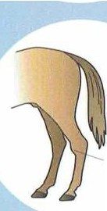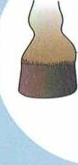

48 HORSEMANSHIP
disappears with exercise. Treatment varies; it could include complete rest, adding mineral supplements to the diet, or surgery.
5WL LLING
HORSEMANSHIP 49

- - - - -- Il'I DING 11OR\ I

Feeding Horses

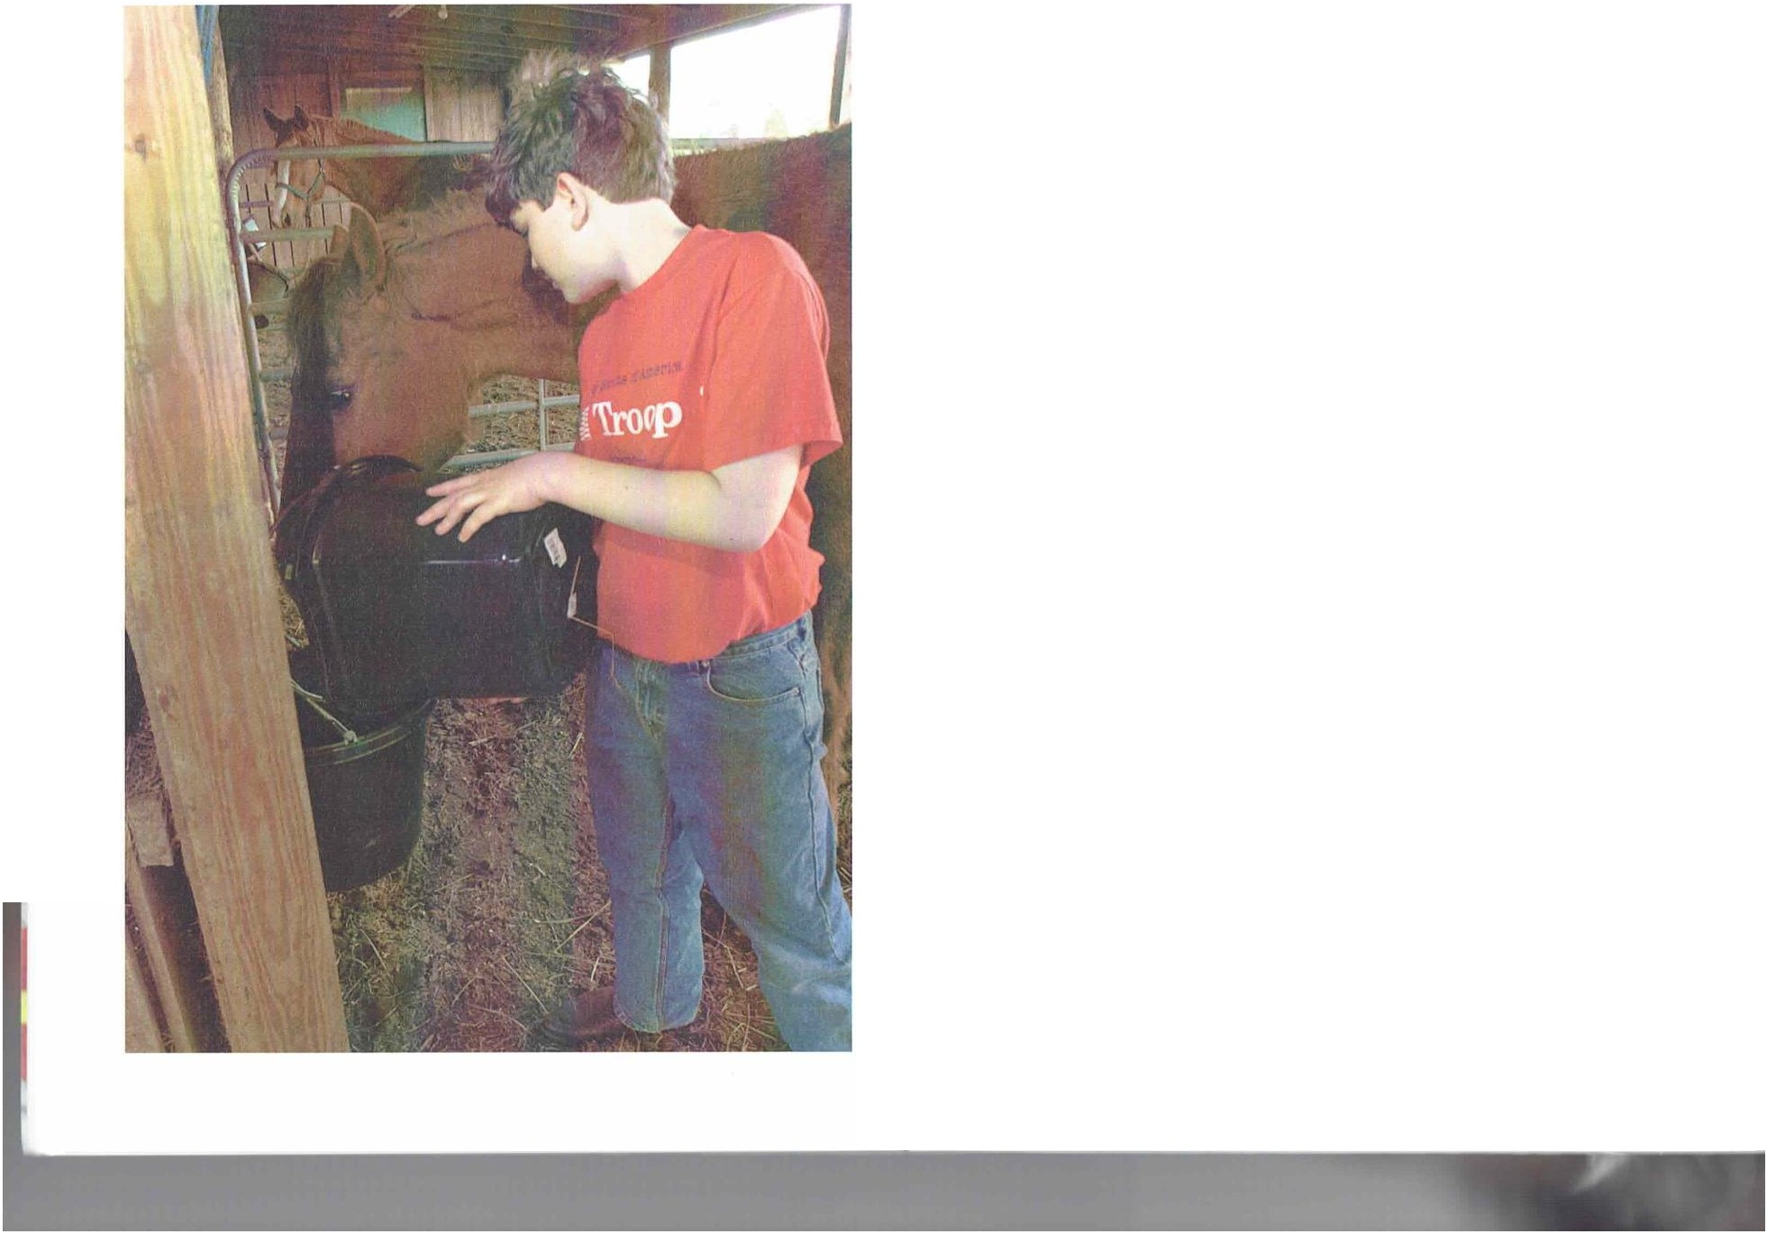
A lthough horses are built to forage, it is not always pract ica l to put a horse out to pasture. So, you will have to feed your horse. When feeding, there are a few rules to follow.
- Provide an amount of feed appropriate to t he horse's activ­ ity level. Too much feed can cause digest ive and circulatory problems. Too Jillie feed can lead to a Joss of energy, and it could harm the horse's overall condition.
- Do not feed a horse that is tired or overheated. Let a horse cooloff sufficiently after exercise or work before allowing it 10 cat.
- W,11cr is critical for a horse's health. It helps produce saliva and other fluids. regulates body temperature, carries nutrients through t he body. and is important for digestion. A horse
can drink from 4 to 15 or more gallons of water each day, depending on the weather, amount of work. and its age and size.
Ilorses have small stomachs and do best when fed a li11le at a t ime and often. After feeding, allow an hour for t he horse to digest the food before exercising or working it.
'lb determine a correct proportion between hay and grain in your area, consult a veterina rian, horse nutritionist, or horse breeder. It is generally suggested that a horse doing light work (one 10 three hours daily) be feel 11;.1 lo 1 1;2 pounds of hay
and 1/i 10 .1 ,1 pound of grain per JOO pounds of weight. It is
best to feed most of the hay (approximately two-t hirds) at night .and the rest in t wo small feedings during the day.
Ilorses working or exercising under saddle for f ve to eight hours a clay need about 1 1;, pounds of hay and 11/•1 or 1 1 /.1 pounds of grain per 100 pounds of weight. It is best
lo divide the food into four feedings during the day.

If your horse is stabled, give it clea n water
before feeding.

HORSEMANSHIP 51

I 111>1 N(, IIOR I - . - -- - - --- - . F t IDINt; I I OR\ I \

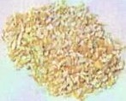
Feeding Tips
  - Clean feed boxes regularly to keep them free of moldy feed.
  - Use only clean, bright, sweet-smelling hay.
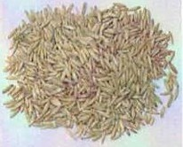
  - Avoid hand-feeding, which can lead to nipping and charging.
•
  - Remember that mares with nursing foals need more protein than other mares, and young horses usually need more protein than older horses.
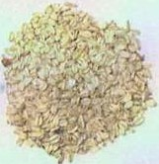
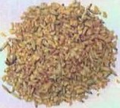
  - Do not store more than a two-week supply of processed grain, and keep feed covered to avoid contamination with rodent feces.

Types of feed include commercial grain mix, bran, barley, hay, oats, com, apples, carrots, supplemental minerals and vitamins, and salt lick. Get a veterinarian's or nutritionist's advice before adding supplements.

Feed Me
Approx imate amount of feed (hay and grain) per day can be determined by the size of the horse and its working conditions. If the horse is healthy,stabled, and not exercising, hay might be all it needs. Consult a veterinarian,horse nutritionist, or horse breeder to help you determine a proper feeding schedule.
Horses need a conslant supply of salt, which can be provided hy it sail lick block or by spreading loose, Irace mineral-lype salt in a shallow box. If you need 10 change the horse's diet ,do so gradually to give ils system lime to adjust.

Horses left to pasture spend much of their time grazing on grass. They often have to eat a lot of grass to gain enough nutrients. If the pasture grass is poor in nutrients and vitamins, concentrated feed mix can help provide a more balanced diet.

Horse's Size
Under 12 hands'
- to 13 hands
- to 14 hands
- to 15 hands
- to 16 hands Taller than 16 hands
Amount of Feed Per Day
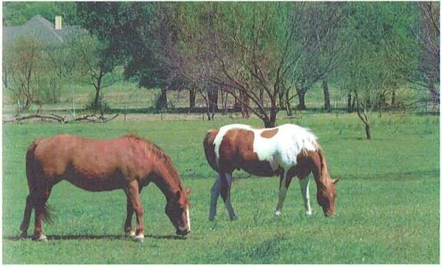
14 to 16 pounds
16 to 18 pounds
20 to 22 pounds
22 to 24 pounds
24 to 26 pounds
26 to 28 pounds

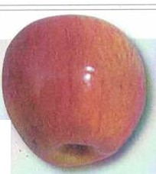"A hand is a unit of measure equalto 4 inches.
52 HORSEMANSHIP HORSEMANSH P 53

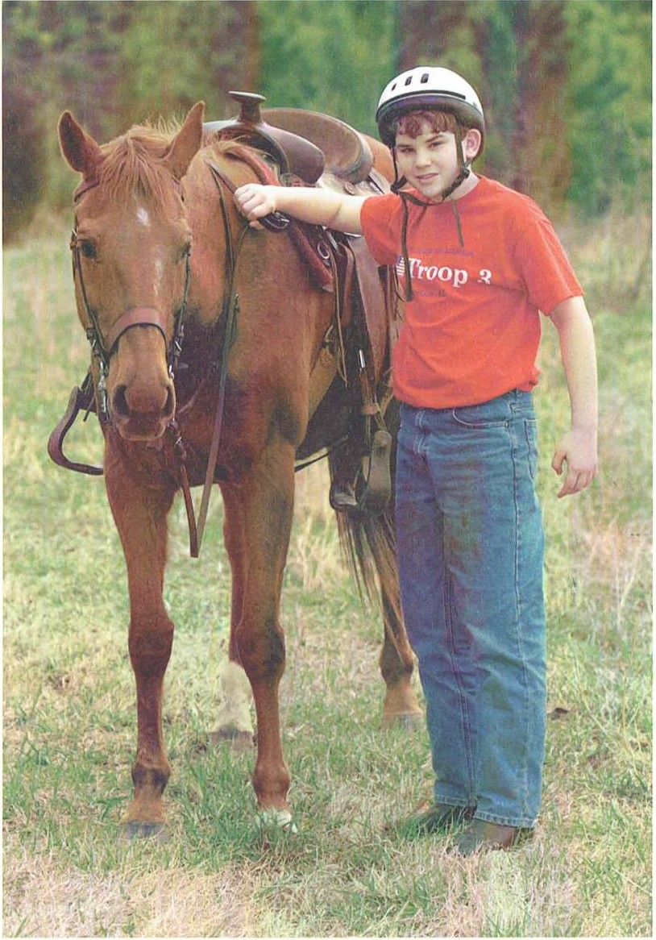
Ready to Ride
RI /\ DY 10 RIDI

Learning how IO handle a horse is jusl .:is much a parlof riding as being in the saddle. A good horseman needs to lea rn how 10
cat ch, lead, turn, back, saddle. and bridle J horse. Never enter
a field of

Catching a Horse
When you first try to catch a horse. have a more experienced person help you. Walk slow ly t oward t he horse at an Jnglc
while talking gent ly to let the horse know you arc there.

Consider renting a good lesson horse by the hour to learn how to ride and perform other merit badge requirements.

Do not chase the horse if it runs. Continue walking slowly toward the horse without looking directly at it , keeping your halter or lead rope drnpcd over your left arm. If the horse does 1101 let you get close, try standing still. II might get curious and come to you. Approac h from the left because that is where you w ill always saddle the horse a nd mount it.

Haltering
Before approaching a horse, unbuckle the halter and allach the rope lo it. Lead ropes arc about S feet long and J/4 inch in diameter with a spring or trigger clip on one end, which at t aches to the halter.

Never approach a horse from behind or unannounced.
horses alone.

HORSEMANSHIP 55

Rl'Al)Y ro RI l)f
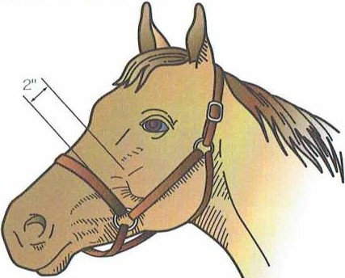
RIADY 1 0 RIDI

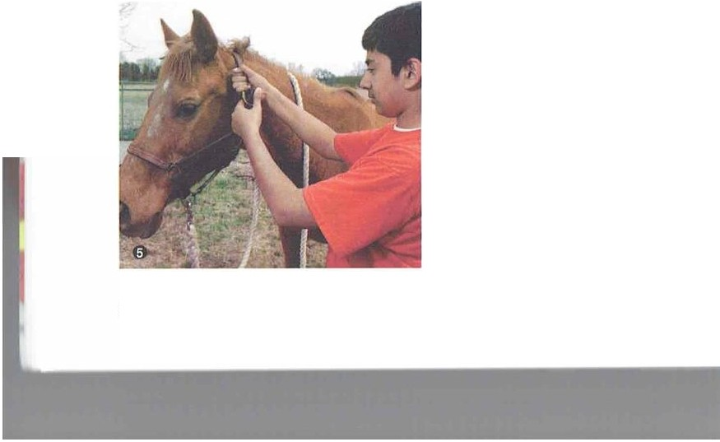

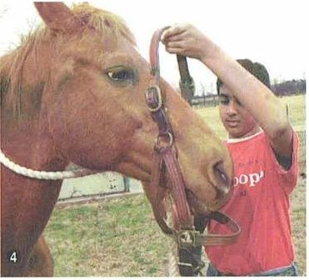

56 HORSEMANSHIP
A correctly adjusted halter should fit snugly, with the noseband 2 inches below the bony point of the horse's cheek.If the noseband is too low, it could damage fragile nasalbones and tissues. If the halter is too loose,it will slide around and could come off.
You should be able to fit two fingers between the horse and the noseband.

Step 1-Approac h the horse from the left shoulder. Talk to the horse gently and reassuringly.
Step 2-Rub the horse's shoulder. then slip the lead rope under the horse's neck with your left hand. Put your right hand over the horse's neck and take the rope from your left hand.
Step 3-Hold the rope together in your right hand to help restrain t he horse. Ilave the rope and halter strap in your left hand and the halter buckle in your right hand.
Step 4-Posit ion the noseband so that t he horse's nose will slide into it. Then raise the halter into position.
Step 5-Position the halter strap over t he horse's head, just behind the ears, then fasten t he buckle. Remove the loop of rope from around the neck.
·10 remove the halter, release the buckle. The halter then can be slipped forward over the nose and removed. When storing the halter, do not let it dangle near the floor
where you or the horse might t rip on it.

Leading
Once lhe horse is haltered, st and on the near side. Take the lead rope in your right hand. right beneath t he jaw. I!old t he slack folded in your left hand with your fingers around the outside of the rope.
Position yourself at t he horse's shoulder and face forward. Now you c.:111 guide t he horse forward using the lead rope. With your right arm near or against the horse's shoulder, you can feel its actions and anticipate its moves. Look where you ilre going (not at t he
horse) and keep a decent pace, but do not rush the horse. If t he horse t ries to get ahead of you, tug light ly a couple of times on the lead rope to slow it down. If t he horse tries to charge ahead, circle the horse around you, using your elbow in its neck if necessary.
Walk calmly but decisively. When you change directions. always turn to t he right.
A trained horse might need only a touch
on the neck to move to the right. Otherwise, you might have to straighten your right
,rm and push the horse's heild or neck.
A lways maintilin your position al the horse·s shoulder. Slow your pace when you want
the horse to slow clown, and gently pull on the lead rope.
Before entering a narrow opening such as a doorway, stop t he horse. If necessary, increase the tension on t he lead to increase your control. Walk through lhe door in
front of the horse. If the horse sta rts lo rush through and you cannot hold it back, do not try to pass it. Stand st ill. 'f\.1rn to face the horse's shoulder, even if you have to let the horse loose. 'fb avoid this sit uation, be sure you have trained long enough so that you
can controlt he horse before trying to lead it through a door or gate.

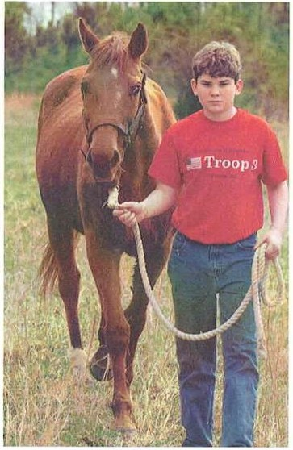
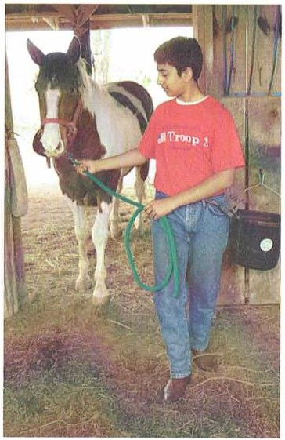

HORSEMANSHIP 57

ltl,\ll\ IO RI ()I

English saddles do not come with girths, stirrup leathers,or stirrup irons. These are sold separate ly. Western saddles, on the other hand, a lways include stirrups and usually cinches, too.

To prevent rope burns and pinches, wear gloves when working with your horse.

Tying
When you tic a horse, use a slrong lead rope; clo not use reins. Make sure to lie t he horse in a safe place away from 01hcr horses, barbed wire, machinery. movable cquipmcnl, and other such objecls. Use a quick-release knot so 1ha1 it can
be undone with one lllg of the free encl in case of emergency.
The tying point should be as high as the horse's he;icl and above the height of its w i1hcrs. If the t ic is low or slips down a pole, the horse could get tangled in the rope. A lso, do not
use a long rope; lhe horse could slep on ii, lrip, or gel f angled. Mind lhe saying, ..Eye high and arm long," when tying a horse.

Saddling
Whether saddling a horse wit h a Western or an English saddle. you w ill follow certain procedures. You might need help controlling the horse the firsl few limes you auempl saddling.
Ilaller the horse and lie il using a quick-release knot.
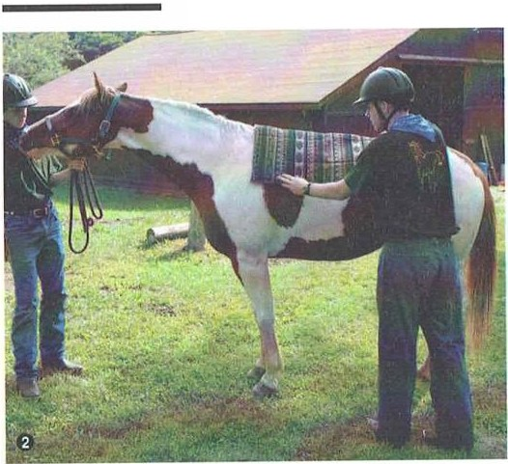
Then brush the horse to remove any caked dirt , remembering its belly and briskelarea. Talk 10 t he horse reassuringly.
\
Step 1-Sha ke out t he
saddle blanket or pad. (Because they are easily frightened, do 1101 do t his with the horse nearby.) Inspect il carefully, remov­ ing any objecls that mighl cause discomforl, such
as burrs.
Step 2-Approaching 1he horse from lhe near (lefl) side, place 1he blankcl or pad well up on 1he wilhers and then drag ii back a few inches 10 smoolh clown
1he hairs.

Illi\nv I() IllI)I

Step 3-Balance the blankcl or pad evenly on the horse. Make sure lhere are no wrinkles.
Step 4-Beforc placing a saddle on 1he horse·s back, lay ;ill of the dangling pieces such as lhe slirrups, cinch, and latigo over lhc lop of the saddle to prevenl lhcm from banging on 1he horse's side and startling it. On an English saddle, run lhe slirrup irons up lhc stirrup lealhers, or cross 1hem securely over the lop of lhe saddle. On lhc West ern saddle, lay lhe cinches, t he right stirrup, s;iddle slrings. and ot her rigging over t he scat.
Step 5-Place your lefl hand in lhc saddle gullcl and the righl hand on the rear skirts.On English saddles, and on Western saddles with a Cheyenne roll on lhc ca ntle, grasp the cant le with the right hand. Lift t he saddle
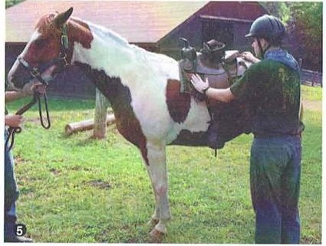
slowly and high enough so that the flaps do not brush against t he horse,
,rnd place lhe saddle gent ly near the horse's withers.
Step 6-Slide the saddle backward until it sits jusl behind the wilhers
Be careful to properly place the saddle on the horse's back, because if it is too far back over t he soft part of the horse's back, it can cause kidney problems or back pain. If it is too far forward, it will restrict the horse's shoulder movement.
Step 7-Reach under t he pommeland lift the edge of the
blanket slighlly Lo give the horse some working space over Be sure to line the withers. An inch of blanket or pad should lie in front of h r h lhe saddle. u1it e c inc
Step 8-Slide both lhe pad and saddle into posi1ion. and slightly behind make sure t he saddle is level. Lift the p.d well into the the front legs. gullet or fork of 1hc saddle. If t he saddle pad has any tabs
or straps to secure it lo the saddle,a1tacl1 t hem. Go to the
right - hand side of the horse and secure the saddle pad on 1hat side also. Then gent ly drop t he girlh or cinches. making sure t hey arc not Iwisted. Pull out any saddle st rings from 11ndcr t he saddle. On a Western saddle, genlly put clown the righ1 s1irrup.On an English saddle.leave t he stirrup irons up until you arc ready to mount.

58 HORSEMANSHIP HORSEMANSHIP 59

RIAIW 10 llilll

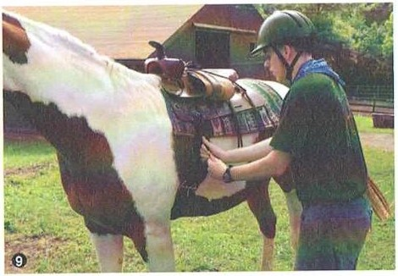
Step 9-Return to 1he near side to cinch the horse. Do not fas­ ten 1he girth 100 tightly at first because the horse will breJthe in and puff out its chest when you first put on t he saddle. After a couple of minutes. w hen the horse breathes out , you can
t ighten the girt h more securely. The girth should fit snugly under the chest or "barrel," behind t he horse's elbows. You
should be able to j ust slide your hand bclween the girth and the horse's skin.
If the horse's skin wrink les under the girth, move the left
foot forward wit h your Joe. Or. pick up t he left front foot firmly
;rnd pull it forward t o get rid of t he wrinkes. Some saddles will have a buckle guard fitted to the girth. Pull t he buckle gu ml over the girth buckles to prevent rubbing.

IUAIW 1 0 Rini

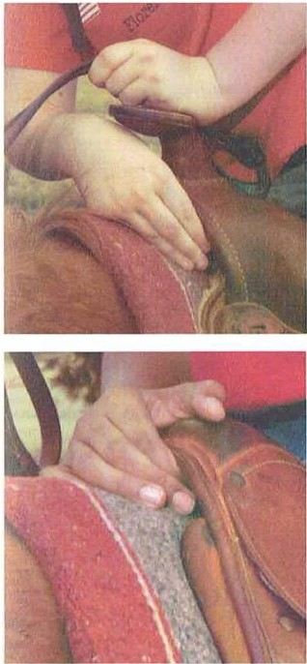
To make sure the Western saddle fits,have an experienced rider mount the horse.With the horse mounted, three fingers should fit between the arch of the pommel and the horse's withers. To make sure that the saddle tree is the correct width,put three fingers with a flat hand sideway s between the saddle and the top of the horse's shoulder.If your hand fits too loosely,the saddle tree is too narrow.If you have to squeeze your fingers, the tree is too wide.

With an English saddle,have someone sit in the saddle with their feet in the stirrups. Again, slide your fingers under the pommel.Three fingers should fit comfortably between the
horse's withers and the arch below the pommel. The saddle should not inhibit the horse's shoulder movement.Then stand behind the horse and look under the saddle. You should see some light between the horse and the saddle when the

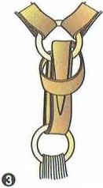Latigo Knot
On a Western saddle, the cinch is formed with a latigo knot.
Step 1-Loosely loop the latigo, or cinch strap, through the cinch ring and Dee ring twice.
Step 2-Pull the latigo out to the side, cross it over the looped latigo, put it up under the Dee ring and then out through the Dee ring.
Step 3-Place the latigo under the crossed-over section and pull it down.
Step 4-Pull up on the cinch and pull down on the end of the latigo to take up the slack and tightenthe cinch.

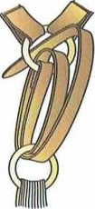
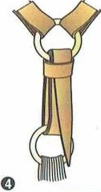
0 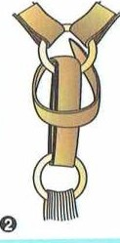
60 HORSEMANSHIP
horse's head is down.

After you have checked that the girth is secure, adjust the stirrups before riding.An experienced horseman can show you how to adjust the stirrups to fit you.

Bridling
Bridle a horse af1er saddling. /\ IIhough the Western and English bridles differ somewhat , t he procedure for bridling is basica lly the same.
Step 1-Gcnlly talk to t he horse while you approach from its left.
Step 2-Unfasten and reposi1ion t he haller around the horse's neck.This way, t he horse remains t ied while you work. Keep
t he reins over your left arm to keep Ihem out from underfoot.
Unbuckle J hc throJt lilich and nosl'llilllll, 1hc11 put Jhc reins uver the horse's head and neck.

HORSEMANSHIP 61

R!Al)Y J O Rini -- - -

Step 3-Hold t he bridle with the bit in your left hand and the t op of the bridle in your right hand. Guide the bit into the horse's mout h while gently pulling up on the bridle with your right hand. You might need to
gently press t he horse's gum at t he gap between t he teeth to get the horse to open its mouth.
Step 4-Continue to gently pull t he bit over the horse's tongue by lift ing the bridle with your right hand and guiding t he bit with your left hand.
Never force the shank of t he bit
bet ween the horse's teeth. If you hurt t he horse's gums, t he horse might resist the next t ime you t ry inserting
t he bit.
Step 5-Use both hands to position t he headpiece. Slide it over the horse's ears, one piece at a lime, over the left ea(
f rst. Be carefulnot to pull on lhe ears.

---· - - - -- - - Rli\lW 10 RIDI

Step 7-Fasten t he noseband, if your bridle has one, so that it fits snugly and inside the
cheekpieces. You should be able to slip four fingers in the space between the t hroat lash and the horse's jaw. You should be able to place one finger between
1he noseband and the horse's nose, and two fingers under the browband.
Step 8-Whcn putting on the bridle, keep your head clear to avoid being hit if 1he horse throws back its head. Before you fasten the buckles, check 10 see that the bit fits the
horse's mouth. If there arc two or three wrinkles at t he corners of the horse's mouth, the bit
is too high.
After the horse is saddled and bridled. lead the horse by holding

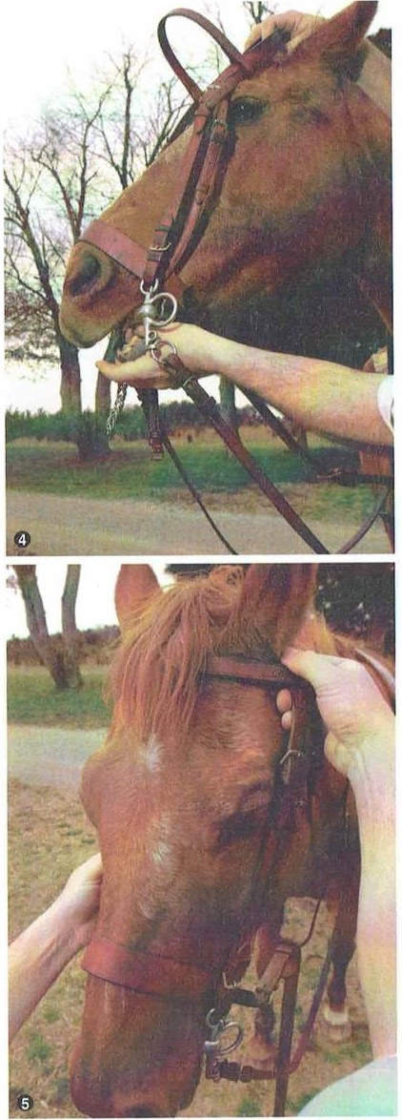
Step 6-Pull the horse's forelock over
the browband. and then check from
the reins under t he bit with your 0
right hand. I!old the other end of

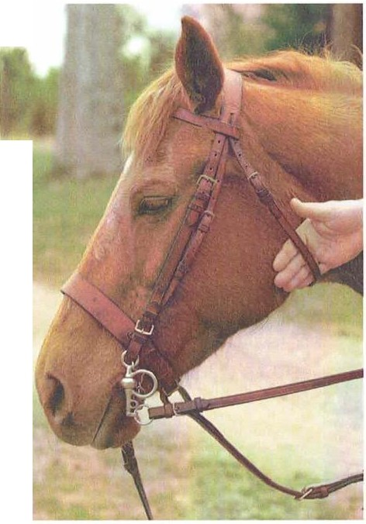

62 HORSEMANSHIP
the front to make sure the bit, nose­
band, and browband arc leveland not twisted. Check again to make sure the bit is over lhe tongue.
the reins in your left hand so that you are leading the horse with both hands. The horse should move just by urging it with the weight of the reins. Do not tug.

HORSEMANSHIP 63

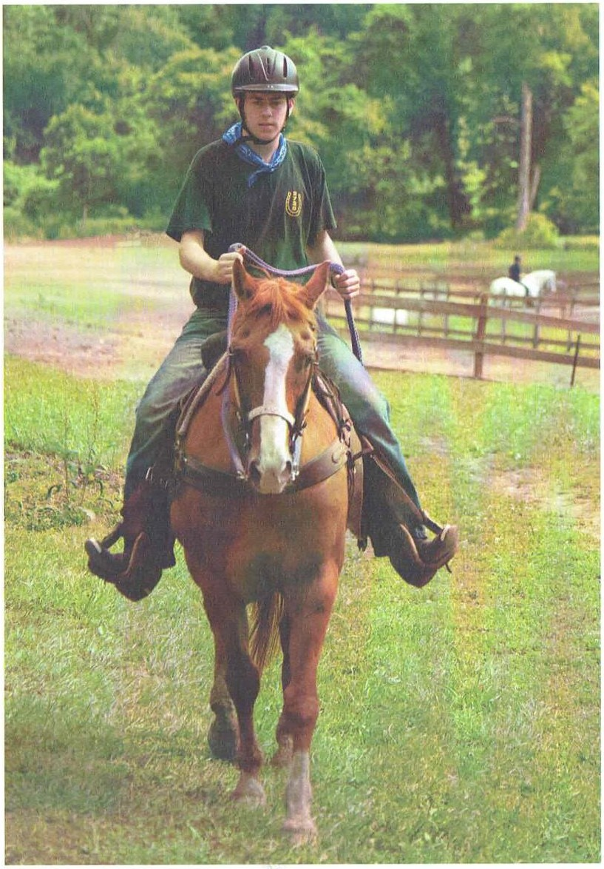
Riding
Riding is basici. lly a mailer of balance and conlrol. You will learn balance wilh praclice, and conlrol w illcome as you learn 1he proper riding techniques. Learning 10 ride correctly requires lime and palience.
I\ good rider keeps arms and hands quiel. moving !hem only back. forlh, or sideways-never up and down. Do not jerk lhe reins, and do not pull or tug very long or you could hurl lhe horse's lender moulh.
Develop a sofl, relaxed, give-and-take grip on the reins lo help maintain easy contacl wilh lhe horse's moulh. When firs! learning 10 ride, lel your hands follow !he bobbing of 1he horse's head by keeping your shoulders.111d elbows loose so 1hey can "open" and "close" w ith !he horse's movemenls.

Even though a horse's mouth is tender, it will resist your pull on the reins. Because a horse can pull harder than you can, it can develop a hard mouth-one that becomes insensitive-if you pull too hard or too long on the reins.

Western Horsemanship
Wes lern riding probably originaled with !he arrival of Spanish conquis1aclors in lhe /\ rnericas in the early 1500s. But Western riding as ii is pracliced loday developed on callle ranches in 1he Weslern Uniled S1a1es and Mexico.
/Is Wes1ern horse shows grew more popular, lhe slyle bec,1mc slanclardized. Wes1ern-s1yle riding includes !rail: show classes, such as pleasure and reining; and compelitions that include rodeo, culling, barrel racing, and pole bending.

RI PlN l,

When learning Western and/or English riding, you will use aids such as your
voice, legs,hands, weight,and
reins to control your horse.

HORSEMANSHIP 65

RIDINl,
ltlDt Nl,

The obv ious difference between Western and English riding is that in most Western show events. the reins are held in one hand only-the left hand. Ilowever, in classes for junior horses, rules allow for two hands wit h certain bits and bridles.
/\lso, Western riders generally do not use their legs to main­ tain a gait. Judges look for slack in the reins, which makes it
important to learn how to controlyour horse w ithout lllgging on the reins.
Western riders should sit tall in the saddle with head up.
back st raight, shoulders level and square, and feet deep in t he st irrups with heels below the toes and knees slightly flexed. Ride relJxed, but alert.

Mounting
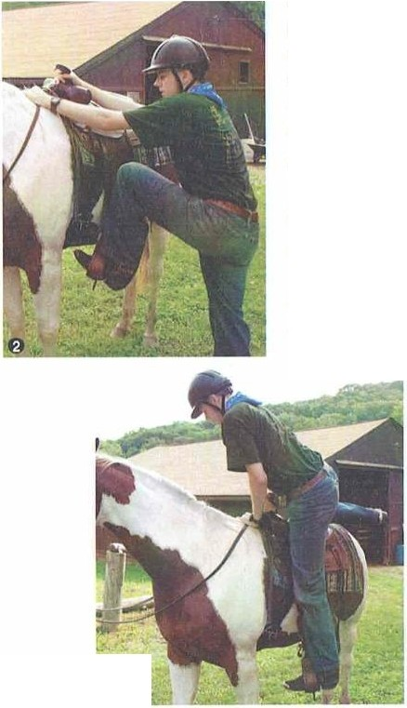
Step 1-Speak gently to the horse as you stand facing it on t he left side, even wit h the saddle. Grasp the reins evenly in your left hand. short enough to stop the horse if it tries to move. Place your left hand firmly on the horse's neck, just in front of the withers.
Step 2-Steady the stirrup with your right hand. Raise your left foot into the stirrup and brace your knee against t he horse.
Step 3-Wit h the foot well into the st irrup, take hold of the saddle horn with your right hand and spring straight up with your right foot until you are standing with your right foot even w ith the
left. Lean forward just enough to keep your balance. Your left hand can rest on the horse's neck.
Step 4-Swing your right leg over the saddle, being careful not to kick the horse. Ease lightly into
t he saddle.
Step 5 -Place your right foot in t he right st irrup. If the horse tries
to move, hold it in check with the reins using your left hand. Hold the reins in your left hand just in front of t he saddle horn. Rest the right hand on your thigh.

Dismounting
Step 1-Place your left hand. holding the reins, on the horse's neck and grasp the saddle horn with your right hand. Lean slightly forward and shift your weight to the left stirrup.
Step 2-Swing your right leg backward over the saddle,again being careful not to hit the horse.
Step 3-Continue to step down, place your right foot on the ground, and remove your left foot from t he stirrup.
Practice so that you can mount and dismount in a smooth, easy movement.

The Gaits
Ilorses have four nat ural gaits-walk, t rot, canter.and gallop­ plus some specialized ones.
The walk is a four-beat gait in w hich the horse's feet touch the ground in even intervals. To move into a walk, lean slightly forward in t he saddle, from the hips up. Shift a little
more of your weight to the stirrups and urge t he horse forward w ith leg pressure. Ilold the reins lightly and do not pull on
the horse's mouth. l<eep your thighs and upper calves in close contact w it h the horse. Ride more forward and not w ith your 5eat on the cantle.
The trot is a two-beat diagonalgait where the opposite
front and hind feet touch the ground together.1b put your horse into il slow trot, take the slack out of the reins to prevent the horse from starting too fast, and lean a little farther forwa rd.
Putting a little more weight in t he st irrups w ill help keep you from bouncing. 10 go to a fast trot, urge the horse to the desired pace by squeezing t he horse with your legs and heels.
In West ern riding, the jog or slow trot is ridden by absorb­ ing the slight jar through your knees and back. With your legs slightly bent and your heels dow n,your knees and ankles act
as shock absorbers. The fast trot , Western style, is ridden by standing slightly in t he stirrups and rest ing your free hand on t he sadd le horn, if you need lo, [or bala nce.
The lope or canter is a rhythmicalthree-beat diagonalgait: ( I) one hind fool hits t he ground, then (2) the opposite front foot and the ot her hind foot hit the ground toget her, followed by
(3) the other front fool. To canter from a walk,gather t he horse slightly in the reins. Pull on the reins slightly to one side and press with the leg on the same side, then release the head. The sudden release and shifting your weight cause the horse to shift

If you are short or have a tall horse, you may have to lean into the saddle, remove your left foot from the
stirrup,and slide down on your right hip to avoid falling or getting your left foot caught in
the stirrup.

RrnlNC
_ _ . ·- _
_ ·- RIDINC.

Beginning English riders must learn to postwhile
the horse trots.
Posting is an up-down
movement that makes the trot more comfortable.
its weight and step out on the fool you have i11dirnted. The horse should break direct ly from a walk to a lope. Don't go into a canter from J trol,because t he horse will learn 10 do lh 11 md
will never be dependable at an extended t rol.
·10 ride a canter, lean forward from the hips up without slumping in the saddle. Give your horse some slack in the reins but do not let them flop. l<eep your elbows near your body JIall
t imes and not flapping up Jnd clown. /\ lways keep your heels low.
The gallop is J series of four beats. but t he sequence of foolfa lls will vary according to the speed. When t he righ1 fore­ leg leads, t he sequence will be lcfl hind leg, righl hind leg. lefl foreleg. right foreleg. This will be followed by a full suspension when all four hooves are off 1he ground. In a gallop. leJn slighlly forward from the hips up and raise your seat slightly. This is a
typicalcue used 10 prompt a gallop.

Reining
In Western riding. horses arc t wght to turn by lhe weight of lhe rein against lhe neck. ·ro turn left, move your rein hand
to the left so that the right rein falls againslthe horse's neck. 'lb go right , move your rein hand to the right.

English Horsemanship
The b;isics of riding are t he same whether lhc s1ylc is Western or English. Ilowever, the styles have different 1racl i1ions, equip­ menl, and purposes. /\lso. English riding techniques involve coordinating 1he legs. reins, and balance to cont rol 1he' horse.
The rider might not feelas secure in an English saddle JS in
t he w ider Western saddle, which has a saddle horn a nd a raised cantle and pommel.
/\mong the events in which English riders can pJrtici­
pate include dressage, hunter or jumper,and eventing or combined training.
Holding the Reins
With a single-rein bridle (see 1), to hold the reins with both hands, each rein should come into your hand under the little finger and pass between the thumb and forefinger, continuing on over the thumb.
To use one hand (correctly,the left hand; see 2), the near-side rein should pass under the little finger and out through the thumb and forefinger. The offside rein should pass through the hand in the oppo­ site direction, and on top of the near-side rein (in through the thumb and forefinger and out under the little finger).
With a double-rein bridle (see 3), to hold the reins with both hands, take the snaffle rein in your hands as described above for the single-rein bridle, leaving the bight of the curb rein on the horse's withers. Keep the snaffle rein in your hands, open up the forefinger and second finger on each hand and with them pick up the curb rein at about the same length as you are holding the snaffle rein.The curb rein should be just a little looser than the snaffle rein.
To pull the curb rein and loosen the snaffle rein, bend your hands down at the wrists toward the horse's withers, rolling the backs of the hands toward each other if necessary to maintain tension.
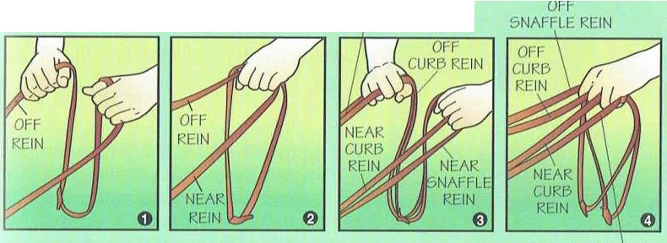To hold double reins in one hand (see 4), the snaffle rein is held the same as for a single-rein bridle; the near-side curb rein should pass between the second and third finger and the off-side curb between the forefinger and second finger, crossing inside, the off side over the near side.
OFF SNAFFLE REIN

In dressage (pronounced dress-AHGE), horse and rider must perform a series of designated movements in an arena before judges.The goal is precision and harmony in movements. The hunter jumper course is an obstacle course over fences that the horse and rider must complete as faultlessly as possible. Eventing, or combined training, is a three-day triathlon for the horse-and-rider team. It combines the skills of dressage, cross-country, and jumping.

68 HORSEMANSHIP

NEAR SNAFFLE REIN
HORSEMANSHIP 69

RIDIN(, RIDJ N<,

English riding clothes include breeches, w hich usually are made of slret ch material and worn with riding boots; a sweater or thick shirt in cold wea ther; jodhpur boots, which are worn w ith jodhpurs (pants made from J wo-way stretch materials
that dl"C' longer tha n breeches); a hacking jacket ; a tie or stock for hunting or hacking; a shirt with collar for showing; string or wool gloves ; and a protective cap. English ridC'rs also carry a jumping, cross-country, or keeper whip to guide the horse using a slight tar; it is never used to discipline or hurt a horse.

Mounting
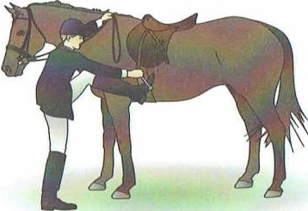
Step 1-1lold the left rein in the left hand. With t he right hand. pull the right rein to take up t he slack on t he off side.
Step 2-With the left rein in the left hand, bring the hand up until it meets the right rein on the horse's neck
just in front of the withers. Take both reins in the left hand. The leftover reins should drop neat ly alongside the
0 shoulder of the horse,and where they
will not catch in the stirrup.
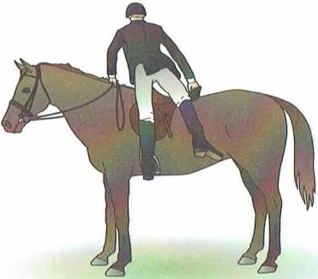
Step 3-0pen the fingers of the left hand enough to grasp a handful of the horse's mane to help pull you up. Do not pull on t he reins when you mount;it will hurt the horse's mouth.
Step 4- 1 1ke the stirrup in your right hand and turn it toward you. Place t he ball of your left foot in t he stirrup, keeping your heel dow n.
Step 5-Grasp t he cantle with your right hand. In a springlike rnovement
0 from your right leg, push yourself up
and stand st raight with the right foot
even with the left and your weight balanced over the horse's back.
Be sure not to jab the horse with your toe.

Step 6-i\s you stand in t he left sJirrup. your weight should he on your arms and left leg. Lea n on your left arm and move your right hand from the cant le to the right-ha nd side of the pommel. i\t the same time,sw ing your right leg over the horse's back.taking care not to kick t he horse.
Step 7-Place your right foot in the right stirrup,settle gently into the saddle, and take the reins in boJh hands.

Dismounting
Step 1-Ga thcr the reins in your left hand on the horse's neck.
Step 2-Place your right ha nd on the pomrnel, then t ake your right foot from t he stirrup and pass your right leg over the horse's back w it hout touching it.
Step 3-Shift your right hand to the cant le.
Step 4-Keeping your weight on your hands. take your left foot from the stirrup and drop lightly to the ground, sliding down the horse's side.

Position and Reining
Keep your head up and eyes ahead. Your back should be stra ight, but not stiff. Keep your arms and hands flexible.
,rnd your elbows bent. The reins should be held evenly
111 each hand in front of the horse's withers and about
l. inches apart.
Sit in the deep part of the saddle, not on the cantle. rhere should be enough space behind you for t he width of your hand. Place the ball of each foot on the inside of the tirrup iron so that your feet are turned out slightly and your
heels hang below your toes. Use your calves to apply pressure to signa l the horse. t<eep your elbows close to your sides.
Both hands hold the reins in English riding,and horses
.ire trained t o respond to direct pressure on the mouth. When using two reins (one pair) , let them pass between the last
two fingers of each hand. up from beneath your hands, and out between the thumb and first finger. Your t humbs should hold the reins in place. The loop that is formed falls over your hands, down to the horse's right shoulder.
You can carry a crop,an English riding whip, when t rotting or cantering. It is held in the right hand along w ith the rein.
lb use it,take holh reins in your lcfJ hanc1 and J ap the horse briskly behind t he girth.

70 HORSEMANSHIP
HORSEMANSHIP 71

RIDINC, ---- --- -- . ---
illl)INC,

1m
.
•A
Ii | -\:  -

-
'

!'!!.-
.
.
Turning
When riding. alwilys look in thr direction you want to go. This includes t urning. The slight change in your weigh! in t he s,1ddlr helps the horse understand your requests. ·10
t urn left. move both hands slightly sideways to pul pres­
sure on t he right side of the horse's neck. Move the hilnds

you up again. A llow yourself to be "thrown" out of t he saddle with each t hrust of a hind leg. and to lrnd back in the saddle
,11 t he insla nl of t he next thrust. Repeat the motion in rhythm with the horse's 111ove111e111.
Don't stand up in the st irrups or heave yourself out of t he s 1dclle. Let the horse do 111ost of the work by giving the push

.i..
·
i'.•..
...
.... .
in t he opposite direct ion to turn right. While walking the
horse, prilcticc t urning in both directions. t hen circle t he horse to the right;me! 10 ihe left.
while you help by holding yourself up momen1arily with your leg muscles.
11 will lake pract ice. Most people find posting the most

"('.- ,r •. ,. i;>.1,;.;.1.....
:1. (' t;,,
M, f ,1,f.. (""
. ,., ;,
t _:."" It._?, ·) n'i '·

; 1\ ''.(,\_;·. ... .

Stopping
Learn how to stop your horse withouljerking bilck or pulling 100 hard on t he reins. This act ion can hurt your
difficult part of English riding. The t rick is to balance from your heels .incl knees. If your heels arc well down and your weight forward, posting is si111ply a matter of rolling onto your knees and rising up and slight ly forward about an inch out of
Don't come down with a thump.You should post at

horse's mout h, and it will cause the horse to begin resist ing you. To stop while English riding. sit down firmly in the saddle.
and set your hands while not yielding 10 t he horse's head mot ion. Be firm on the reins, but gent le.

Riding the Canter (English)
Because of its easy rolling mot ion, 1he lope or canter is prob­ ably the most popular gait. A t t he canter, your hands continue tu rest rain tou 111ud1 forward move111cnl while remaining easy on t he horse's mout h. Your weight should be more on your knees than heels. You rock gent ly forward and clow n as the horse moves away beneillh you and rises again at t he next
stride. Once you have t he feel of it, ilis easy to relax and let
t he saddle.
You can t hrow your mount off b,1lance if you post on the w rong diagonal. In a small circle at a fast t rot you can throw your horse to t he ground. Remember, post on t he outside di,1gona l-1he leg next 10 the rail in .in enclosed area.
·rb change diagonals. as you would in a figure eight at the
i111ersec1ion of t he two circles.don·1 rise on t he count. Inst ead, skip one beat and rise on t he following count. You wil l t hen be on t he opposite diagonal.

Correcting Poor Habits
the same speed
as the horse trots and change
speeds as he goes faster or slower.

It is best to break a horse into the canter from
a walk.

72 HORSEMANSHIP
your body follow t he motion of t he horse.

Posting theTrot
Once you have learned how to walk, turn, slop, and back your horse, you arc ready to go to the t rot. In English riding. you should learn to JXJSI. This in an up-clown. up-down movement
that makes the t rot more comfortable for bot h you and the horse.
Shorten the reins, bend slight ly forwa rd, and use your legs or heels to urge your horse from a walk into a t rot. f'or a
moment just sit there, lett ing your knees and ankles absorb t he shocks and jolts.
'lb post, use your thigh muscles to hold yourself in the air while the horse's hooves st rike t he ground, t hus avoiding t he jolt. Then let yourself clown until lhe horse's leg act ion pushes
To prevent a horse from developing and keeping poor habits, correct
them as quickly as possible.
Do not let the horse head for the barn, stable, or its "home" every time it is near. Practice riding the horse in front of the stable or barn without letting it stop there. When you are ready to dismount, ride away from the barn, stop,dismount, and lead the horse back to the stable or barn.
When a horse attempts to bite, push it away and say "No!" in a firm voice. Praise the horse when it does not try to bite. If a horse bites, you need to find out why. It could be that the horse expects a
treat. Restrict or quit giving treats, if this is the reason. A horse might
bite during grooming or cinching if you are careless or too rough.
If a horse ever attacks with its teeth, do not attempt to deal with it.Seek the advice of a horse expert.
HORSEMANSHIP 73

Il l)IN(,

Never back a horse by pulling or jerking on the mouth!

Backing While Mounted
Backing while mounted is helpful w hen you need lo back up a few steps lO gel out of a t ight spol on the t rail. Walk your horse forward, gent ly bul firmly rest rict ing the motion so t hat your horse lift s ils leg forwa rd t hen drops ii back because ii
cannot go forward without straining t he rein. The horse should only back one. two. or t hree steps. Keep your horse quiet. calm,and st raight while backing.

Backing Up Straight
As you leach your horse 10 move backward w it h a haller, remember t hat horses dislike moving backw,. rrl. Your horse's first reaction might be lo raise it s head and plant its hind feet. Ilowevcr, there is an effect ive way to teach your horse lo back up.
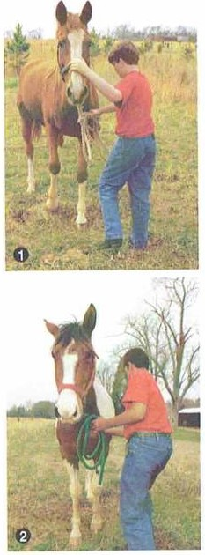
Step 1-Stand on t he left side of the horse, near the withers, with the lead rope in your right hand. Use the
rope to bump t he horse's forefeet back while using your left hand lo keep the horse's nose st raight. You might need someone else 10 help. Just move t he horse back a step c1t a time w hile s;iying "back." II might help lo have t he horse focing a wall so t hat ii can·, go forwa rd.
Step 2-lf t he horse won' t move, push the horse al t he chest , where the muscles join. App ly pressure until t he horse steps back.Then release and repeat.
As the horse learns 10 move back.touch ii lightly on t he chest less and less often unt il it backs with just t he pres­ sure from t he halter rope or when you say "b,Kk."

Unsaddling
After your ride, make sure t he horse has cooled off and relaxed before taking it to the stable or barn. When you have stopped the horse, pal ii on the neck. Now dismount 10 t he left , and lift the reins over the horse·s he.id.
After dismounting an English saddle. run the st irrups up the leathers , making sure they do 1101 flop. Unbuckle
the girth on t he near (left) side of the horse and lay ii over Ihe seat.
On a Western saclclle, lay the ..left" st irrup over t he saddle
or hook t he st irrup on the horn. Untie the l,1ligo knot and

completely release t he cinch.·r::ike t he cinch (la tigo) st rap and wrap on the front D-ring a couple of limes lo ensure that ii docsn·1 clrag on the ground. Move to the off (right) side of your horse and lit' 1hr cinch using the saclclle strings or the cinch tab.
Place one hand on the pommeland t he ot her hand on the cant le. Lift the saddle off t he horse's back and sci the saddle on the ground. It is usually best lo prop ii against a wall with
the pommel clown.
Before laking off t he bridle,strap a halter 1round the horse's neck so that you can maintain cont rol. Undo the noseband and the t hroat lat ch from the bridle, and lift t he headpiece ann reins together over t he ears. The bil w ill drop from the horse's mout h when you do this.
Next, fasten t he halter and tic t he horse w hile you put your lack away.
There are two ways 10 carry a saddle. One way is to place it on your right arm with the pommel in t he crook of your elbow and t he cantlc encl in your left hand. The second is
lo put t he headpiece of t he bridle and the reins on your lcfl shoulder. This will leave your hands free 10 c, rry the saddle.
Last ly, groom your horse and clean the tack.

Stable Safety
In case of an emergency, it's important lo keep certain it ems handy in t he stable. Spot lights. flashlight s, fire extinguishers,
,rnd ropes w ith easily loosened knots or snap fasteners all are items t hat may be necessa1y in an emergency.

Fire PreventionTips
- Stable horses in a building separate from machinery, fuel, lubricants, paint. and fertilizers.
- Store feed and bedding in a building separat e from where horses arc stabled.
- Keep matches and flammable materials outside t he stable area.
- Pile manure away from the stable because manure builds heat.
- Buy or store only well-c ured hay and bedding. Damp grass is a hazard because ii builds heal and might ignite by sponta neous combust ion.
- Do 1101 allow smoking in the st able area.

- Rll)INt;

As you remove the bridle, do not pullthe bit from the horse's
mouth-you might hurt the horse. Let the bit fallout as you remove the bridle.

Keep a halter with a lead rope on each stall door. In case of an emergency,you won't have to
look for one for each horse.

HORSEMANSHIP
HORSEMANSHIP 75

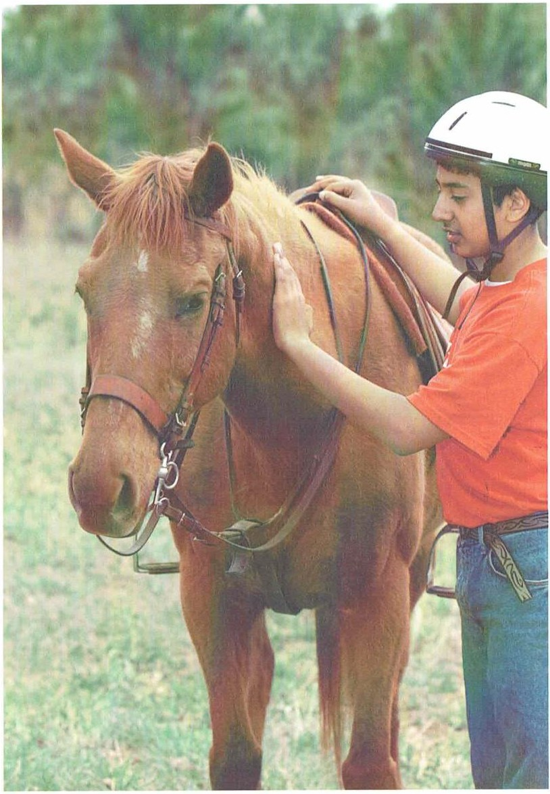
IIOll\l.MAN\1111' ANll Yllll

Horsemanship and You
By now you know what il tJkcs to be a kind and responsible horseman. Just remember to praclicc your riding and handling skills slowly and melhodically. l\s you do, you will notice 1h;i1 you become more co111for1ablc and many of 1hc skills
will become second nature. If you arc consistent with your h,1ndling and riding skills, you will be ,1ble lo work with any kind of horse.
It is important to be respect fulof horses· nature.
Remember that 1hey do 1101 t hink like people do, but if you communica le with lhem in ways 1hey understand. they make wonderful co111p,1nions and riding partners. One of the most rewarding things about horsemanship is 1hc deep and lasling truslyou c,1n have wit h your horse.
You might discover that you enjoy horsemanship enough to own your own horse or to compete in rodeos or jumping cvems. Whe1hcr you use your horsemanship skills for pleasure rides or competition, horsem;rnship is more than just riding a horse; ii is a practice of respect for horses and your rcl11ionship wilh !hem.

HORSEMANSHIP 77

IIOR\I M/\N\ 11 1 1' R I\OllRU \ - --
IIOR\IM.\N\1111' RI \IHlllt I·\

Horsemanship Resources

National Reining Horse Association 3000 NW 10th St.
Oklahoma Cily, OK 73107
·1elephone: 405-946-7400 Website: h1tp://www.nrha.co111
Pony of the Americas Club 3828 South Emerson /\ve.
Indianapolis, IN 46203 lclephone: 3 1 7-788-0107
Webs it e: hltp://www.poac.org

pamphlet. The Commiltee and Council gracious ly hosted i1 photo shoot al t heir summer Ilorse Camp, and a number of
t he images shot there can be seen herein.
Thanks to Susan /\. Ilerking of
t he Certified Ilorsema nship Associat ion and Inst ructional Services Inc., and Phil Pet erson. director, Miracle Ranch,
Poulsbo. Washing1on. in preparing the 2003 revision of t his merit badge

Scouting Literature
Fielcl/Jook: Animal Science, Mammal SIUcfy, and Veterinary Medicine merit badge pamphlels

Visit the Boy Scouts of Amer ica's official retailwebsite at http:// www.scoutstuff.org for a com­ plete listing of all merit badge pamphlets and other helpful Scouting materials and supplies.

Books
Benne11- 1albot , Betty. Games 011 llorse/Jack. Storey Books. 1999.
Edwards, Elwyn. The New Encyclopeclia of the I lorse. DK, 2001 .
Ilaas,Jessie. Safe Horse. Safe lide,:
Storey Books, 1994.
Ilarris, Susan. United States Po11y Club Ma11ual of Horse11ta11ship: Basics for Begi1111ers. Howell Book Ilouse, 1994.
1layes, Karen. I lands-On Horse Care.
Trafalgar Square Press, 1997.
Ilenderson, Carolyn. The New Book of Sadclle,y rmcl "lack. Sterling, 2002.
Ramey, David. Co11cise Guide to
Nlllri1io11 i11 the Ilorse. Ilungry Minds, 1998.
Rodenas, Paul. Random Ilouse Book of I lorses and / lorsemanship. Random
!louse, 1997.
Vogel, Colin. The Complete llorse Care Manual. DK. 1995.

Magazines
I/orse //111strated
P.O. Box 8237 Lexington, KY 40533 Website:
ht tp://www.horsechannel.com/horse­ magazi nes/horse-i11ust rated
Horse & / icier
Website: hltp://www.equisearch.com/ horseandrider
Pmclical f-lorsema11
Website: http://www.equisearch.com/ practicalhorsem;in

Organizations andWebsites
International Equestrian News Network
P.O. Box 227
Marshfield Hills, Mi\ 02051

United States Dressage Federat on 4051 Iron Works Parkway
l.exinglon. KY 40511
·1elephone: 859-971-2277 Websilc: htt p://www.usdf.org
United States Equestrian Team Foundation
1040 Pottersville Road
P.O. Box 355
Gladstone, NJ 07934-9955
·1elephonc: 908-234- 1251 Website: http://www.uset.com
United States Eventing Association 525 Old Waterford Road NW Leesburg, Vi\ 20176
Telephone: 703-779-0440
Website: htt p://www.usevenling.com
The United States Pony Clubs 4041 Iron Works Parkway Lexington, KY 40511
Telephone: 859-254-7669
Webs it e: htt p://www.ponyclub.org

Acknowledgments
The Boy Scouls of America gratefully acknowledges the assistance of the Horse
Trail Guide Committee of the Greater
pamphlet. Thanks also to Dr. Dale
Linebaugh. director. Miracle Mountain Ranch Missions, Spring Creek, Pennsylvania, and to riding ins1ructor and t rainer Don Matschull, Plano, Texas. for their expertise and assistance.
We appreciate the Quicklist Consulting Commiuee of the Association for Libra1y Service to Children, a division of the American Librilry Assoc iation,for its assistance with updating the resources section of lhis merit badge pamphlet.

Photo and Illustration Credits
American Morgan Ilorse /\ssocialion, courtesy-page 18 (Morgan)
American Quarter /-lor se Joumal,
courtesy-page 19 (top)
Bana naStock- page 37
Chris Evans, Riverlo River CWMA, Bugwood.org, courtesy-page 44 (/Jracken fem and yew tree)
Mary Ellen Harte, Bugwood.org, counesy-page 44 (rag1uort)
Im Your Gold Huckleberry, rennessee Wa lking Horse Slallion,owned
by Mary Binner of Deer Creek

I!ill, Cherry. 1/orse lln11rlling and Grooming. Storey Books, 1997.

78 HORSEMANSHIP
lelephonc: 781-834 -7137 Website:
htlp://www.equestriantimes.com
St. Louis /\ rea Council wit h this revision of the Ilorsemanship merit badge
Walkers, Quitman. ·rexas,
courtesy-page 13 (palomino)
HORSEMANSHIP 79

